School Name
Yearly Examination
2016
Year 10

Advanced Mathematics Course
General Instructions  - Reading time: 5 minutes  - Working time: 2 hours  - There will be a short break between Section 1 and Section 2  - Write using black or blue pen  - You may use a pencil to draw or complete diagrams  - Attempt ALL questions  - Approved calculators may be used in Section 2.  - Write your Name and Teacher’s Name in the spaces provided.  - A formula Sheet is on the reverse of this page and can be detached and used in all sections of the test. | Total Marks – 100  Section 1  Non Calculator Section.  25 marks  Time allowed for this section is 30 minutes.  Write all answers in the spaces provided.  Section 2  Time allowed for this section is 1 hour and 30 minutes.  Part A  Multiple Choice Section.  Mark your answers on the separate answer sheet at the end of the examination.  50 marks  Part B  Longer Answer Section.  Write all answers in the spaces provided.  25 marks

Formula Sheet
Pythagoras’ Theorem
c = hypotenuse
a and b are the shorter sides

Circumference of a circle
d = diameter

Area of a circle
r = radius

Area of a parallelogram
b = base
h = perpendicular height

Area of a rhombus or kite
x and y are the diagonals

Area of a trapezium
h = perpendicular height
a and b are the parallel sides

Volume of a prism
A = area of base
h = perpendicular height

Volume of a pyramid
A = area of base
h = perpendicular height

Volume of a cylinder
r = radius
h = perpendicular height

Volume of a cone

Volume of a sphere
Surface Area of a Cylinder

Surface Area of Cone
r = radius
l = slant height

Surface Area of a sphere

Trigonometric formulae for a triangle ABC.

Sine Rule

Cosine Rule
or
Area of a triangle
Simple interest
P = Principal
R = interest rate per time period as a decimal
T = number of time periods

Compound Interest
A = Final amount to which the investment grows
P = Principal
r = interest rate per compounding period as a decimal
n = number of compounding periods
Depreciation
SV = Salvage Value to which the initial value falls
IV = Initial Value
r = depreciation rate per compounding period as a decimal
n = number of compounding periods

Gradient of a line
and are points on the line
m = gradient

Midpoint of a line segment

Length of a line segment
Equation of a line
or
b = y intercept

School Name
Yearly Examination
Advanced Mathematics Course
2016

Class/Teacher ______________________

Name______________________

Section 1

25 marks
Time allowed for this section is 30 minutes

Answer Questions 1–25 in the spaces provided.

Calculators are NOT to be used in this section.

There will be a short break between Section 1 and Section 2.

Section 1 Non Calculator Section
 | Write all working and answers in the spaces provided on this test paper.
1. | A bus has 35 passengers of whom 28 are children and the rest are adults.  What percentage of the passengers are children?  ……………………………………………………………………………………………....  ……………………………………………………………………………………………….
2. | 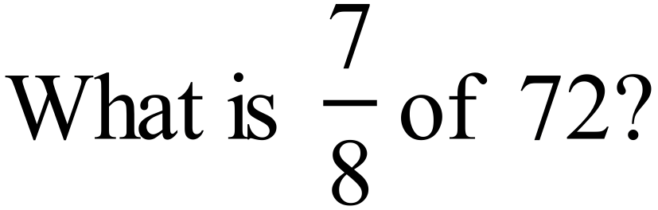  ……………………………………………………………………………………………....  ……………………………………………………………………………………………….
3. | 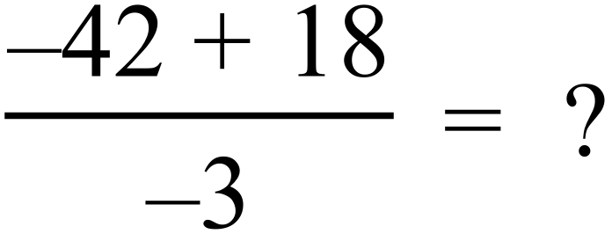  ……………………………………………………………………………………………....  ……………………………………………………………………………………………….
4. | 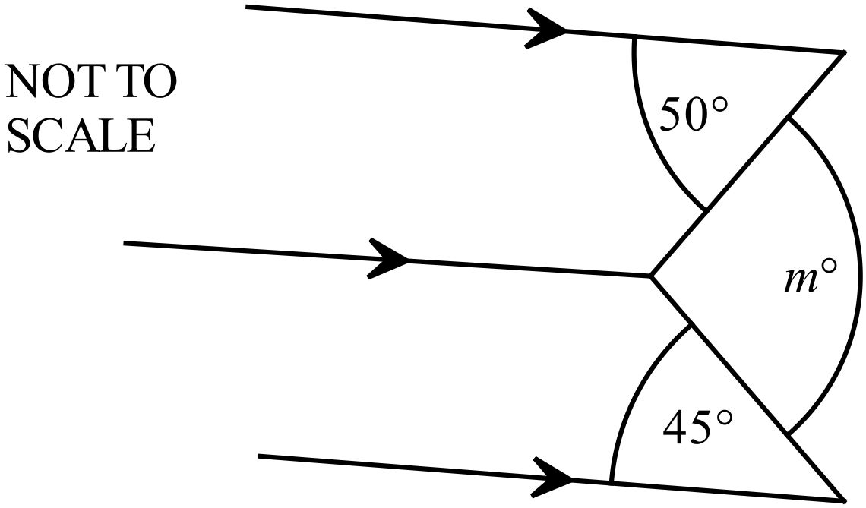Find the value of m in this diagram.  ……..…………………………………………  ……………………………………………….  ………………………………………………  ………………………………………….……
5. | What is the value of x in the quadrilateral below?  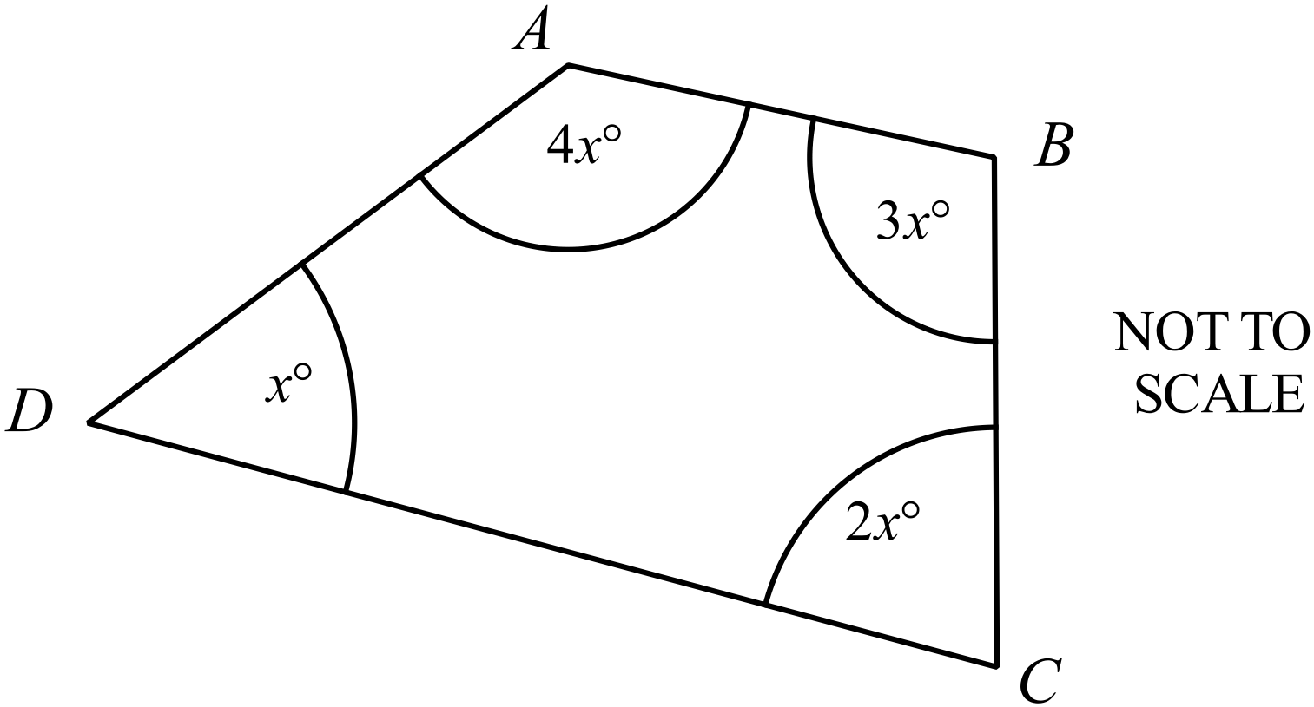  ……..…………………………………………  ……………………………………………….  ………………………………………………  ………………………………………….……
6. |   In November, Glasgow time is 9 hours behind Sydney time.  A soccer match is to be played in Glasgow, starting at 1:45 pm on Saturday 12th November.  At what local time in Sydney would the game begin?  ………………………………………………………………………….  ………………………………………………………………………….  …………………………………………………………………………
7. | 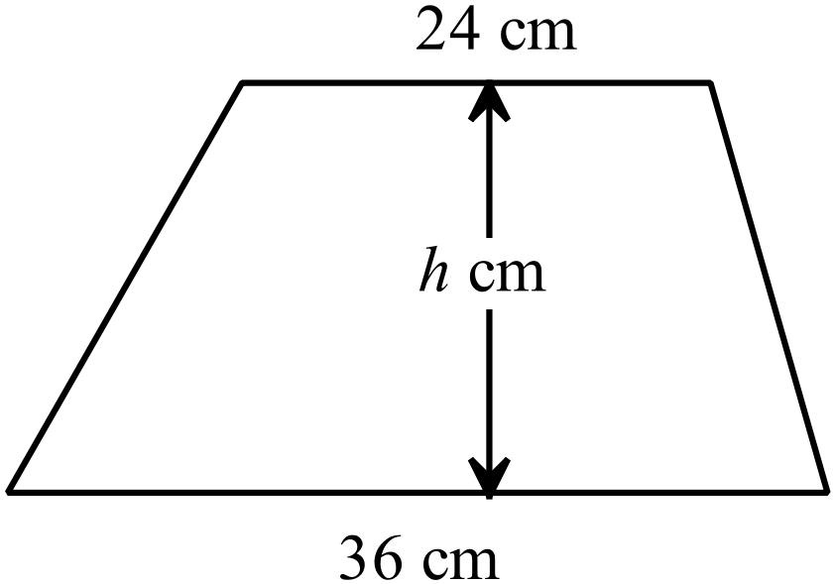The trapezium shown has an area of 540 cm².  What is the value of h?  .……………………………………………………  …………………………………………………....  ……………………………………………………
8. | Blake plans to lay a slab of concrete in the shape shown.  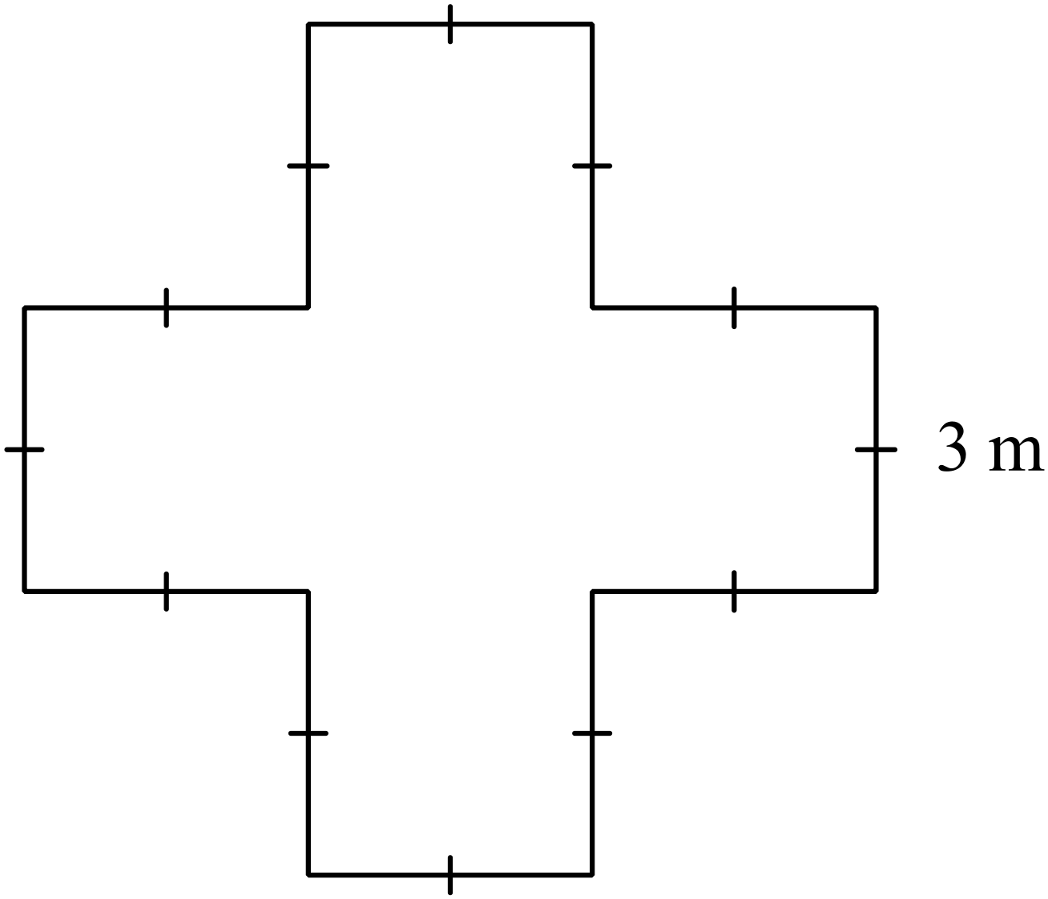All angles are right angles and each side measures 3 metres.  The slab is to have a uniform thickness of 20 cm.  How many cubic metres of concrete is needed for the slab?  ……………………………………………………  ………...………………………………………....  ………...………………………………………....  ……………………………………………………
9. | Use the formula 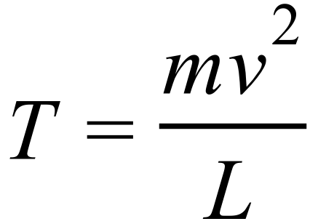 to find the value of T when  ……………………………………………………………………………………………....  ……………………………………………………………………………………………….
10. | Expand and simplify 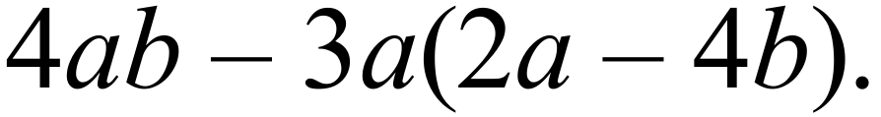  ……………………………………………………………………………………………....  ……………………………………………………………………………………………….
11. | 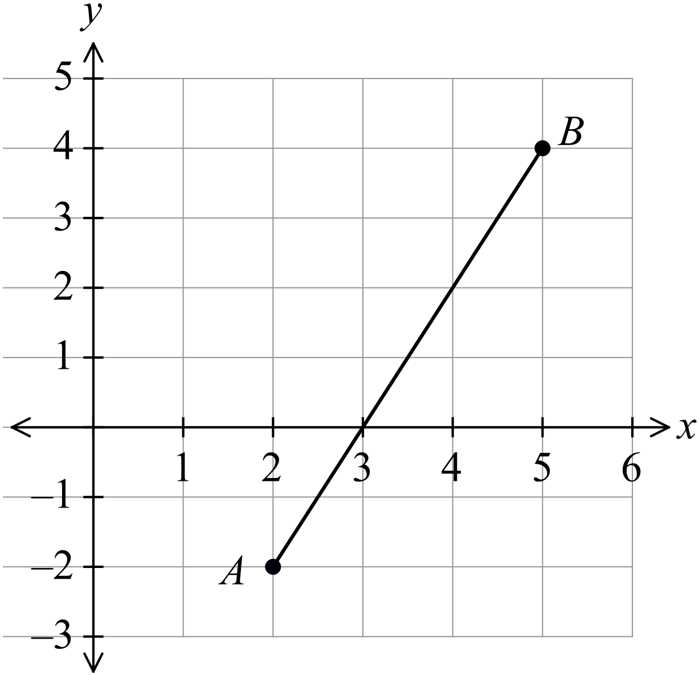What is the gradient of the interval AB on the number plane shown?  ……………………………………………  …………………………………………....  ……………………………………………  …………………………………………….
12. | Simplify 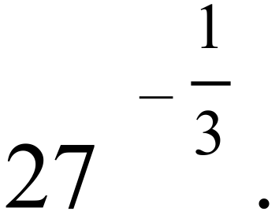  ……………………………………………………………………………………………....  ……………………………………………………………………………………………….
13. | Find the value of d for which 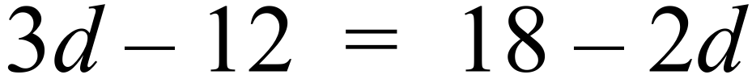.  ……………………………………………………………………………………………....  ……………………………………………………………………………………………....  ……………………………………………………………………………………………….
Questions 14 and 15 refer to the following:
Six girls contributed photographs for a school magazine.
The graph shows their contributions.

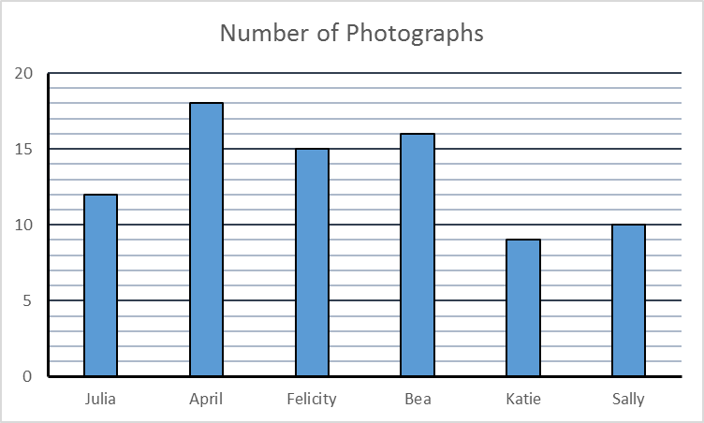
NAME
NUMBER OF PHOTOGRAPHS

14. | What percentage of the photographs did Bea contribute?  ……………………………………………………………………………………………....  ……………………………………………………………………………………………….
15. | What was the mean number of photographs contributed by the girls?  Answer as a fraction in simplest form.  ……………………………………………………………………………………………....  ……………………………………………………………………………………………….
16. | Jason took part in two fun runs.  He took 2 hours and 20 minutes for the first run and 1 hour and 45 minutes for the second run.  What is the ratio of his times to complete the two runs?  ……………………………………………………………………………………………....  ……………………………………………………………………………………………….
17. | What is the midpoint of the interval joining P (-6, 10) and Q (4, 5) ?  ……………………………………………………………………………………………....  ……………………………………………………………………………………………….
18. | What is the value of 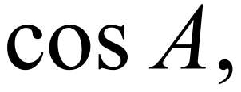 in the triangle ABC?  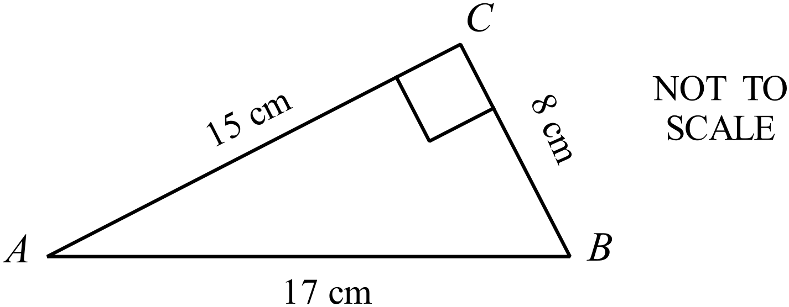 ……………………………………………………  ………...………………………………………....  ………...………………………………………....  ……………………………………………………
19. | 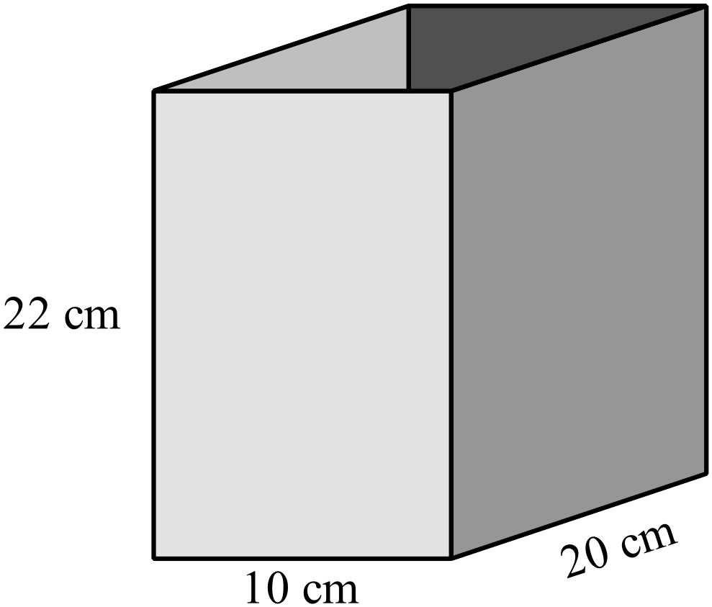The storage box shown is open at the top and made from cardboard.  What area of cardboard in used to make the box?  ……………………………………………………  ………...………………………………………....  ………...………………………………………....  ……………………………………………………
20. | A grain hopper is in the shape of a square pyramid as shown.  What volume could the hopper hold when full to the top?  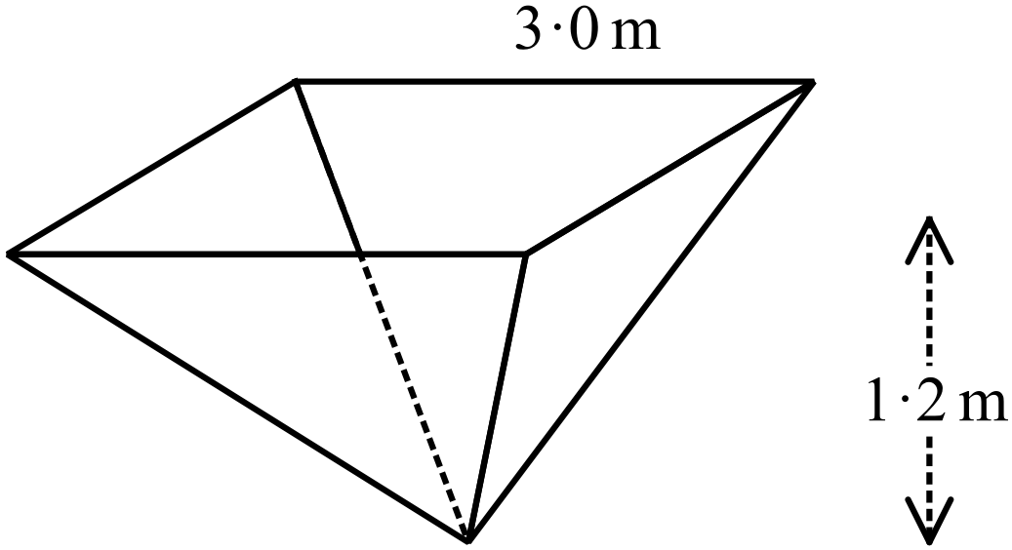  ……………………………………………………  ………...………………………………………....  ………...………………………………………....  ……………………………………………………
21. | Draw the image of the figure PQRS when it is reflected in the line AB.  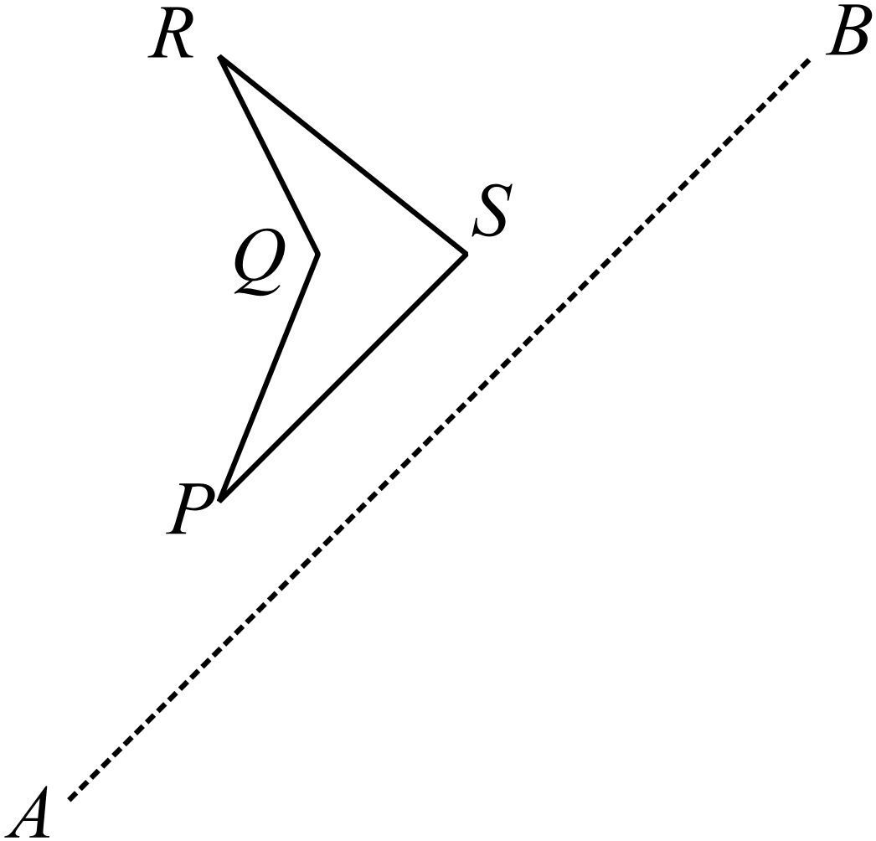
22. | 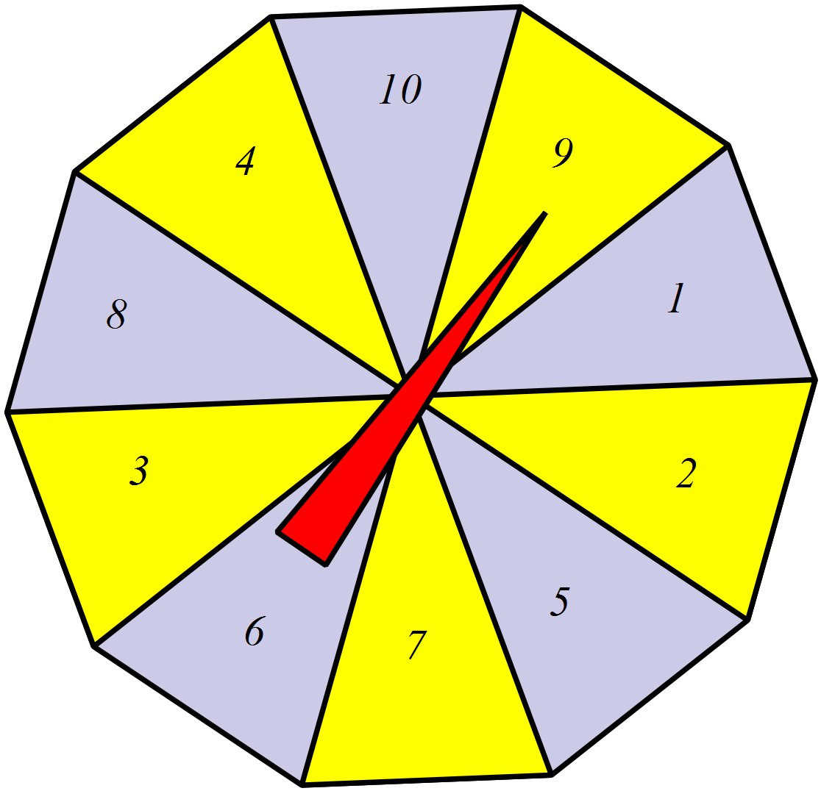A spinner has ten equal sectors numbered 1 to 10 as shown.  On a single spin, what is the probability that the spinner lands on a number which is divisible by 3?  ………………………………………………………………….  …………………………………………………………………
23. | 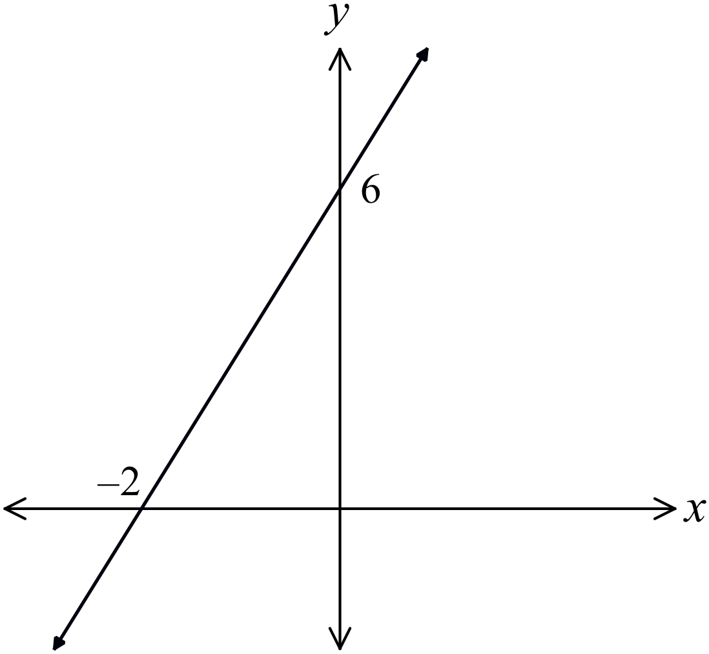Determine the equation of the line shown on the number plane.  ………………………………………………  ……………………………………………....  ………………………………………………  ……………………………………………….
24. | 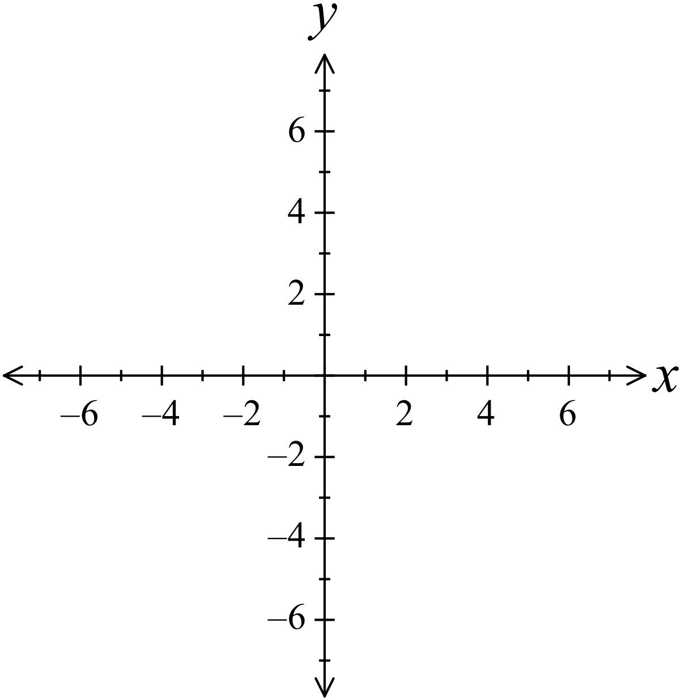Sketch the curve 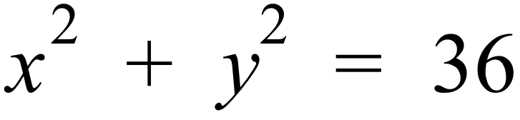 on this number plane.  ………………………………………………  ……………………………………………....  ………………………………………………  ……………………………………………….
25. | 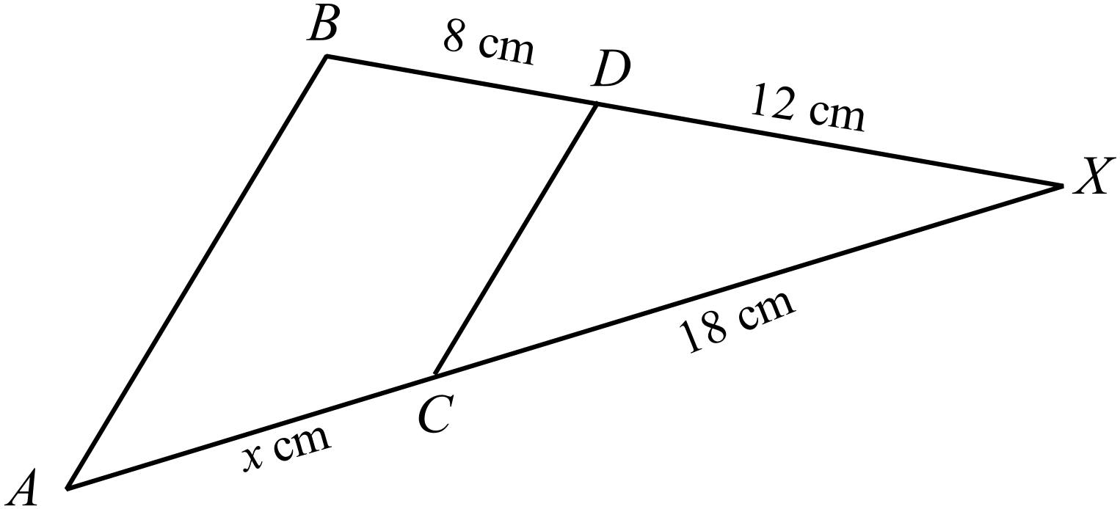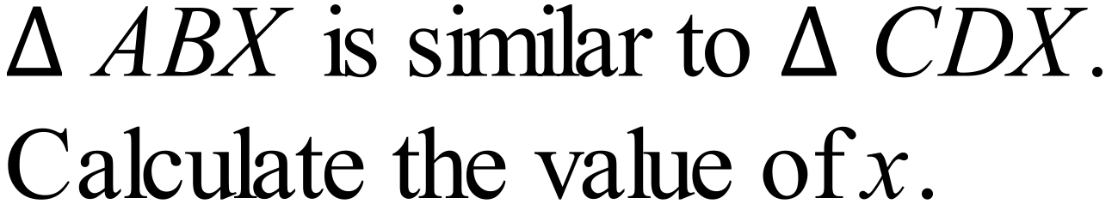  …………………………………………  …………………………………………  …………………………………………  …………………………………………

End of Section 1

Fallow Page
School Name
Yearly Examination
Advanced Mathematics Course
2016

Section 2

75 marks
Time allowed for this section is
1 hour and 30 minutes

This section has TWO parts

Part A – Fifty multiple-choice questions worth 1 mark each.
Mark your answers on the separate answer sheet provided at the end of the examination.
Part B – Longer answer questions worth a total of 25 marks.
Write all answers and working in the spaces provided on this examination paper.

Calculators may be used in this section.

Do not commence Section 2 until you are instructed to do so.

Section 2 - Part A
Use the multiple choice answer sheet at the end of the paper to record your answers.
Complete shade the bubble corresponding to the correct answer for each question.

Which of the points represent the position of 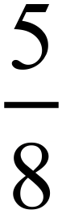 on the number line?

A. Point A B. Point B C. Point C D. Point D
Neil invests $6 400 in an account that pays 6% p.a. simple interest.
How long will he need to leave the money invested to earn $672 in interest?
A. 1 year and 8 months B. 1 year and 9 months
C. 1 year and 10 months D. 2 years
In the diagram below, CF and EG are straight lines and  is a right angle.
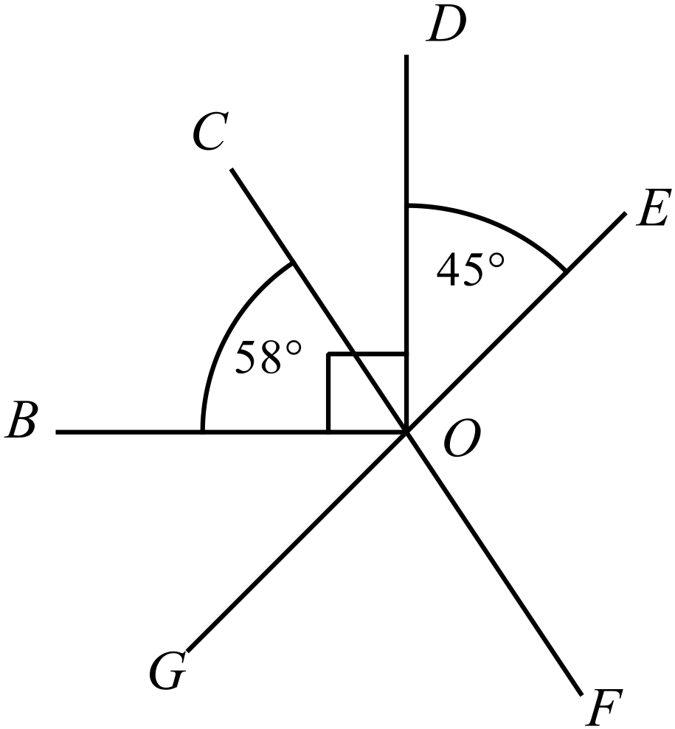Also
What is the size of 

A. 103º
B. 122º
C. 135º
D. 148º
What is the value of  in the diagram below?
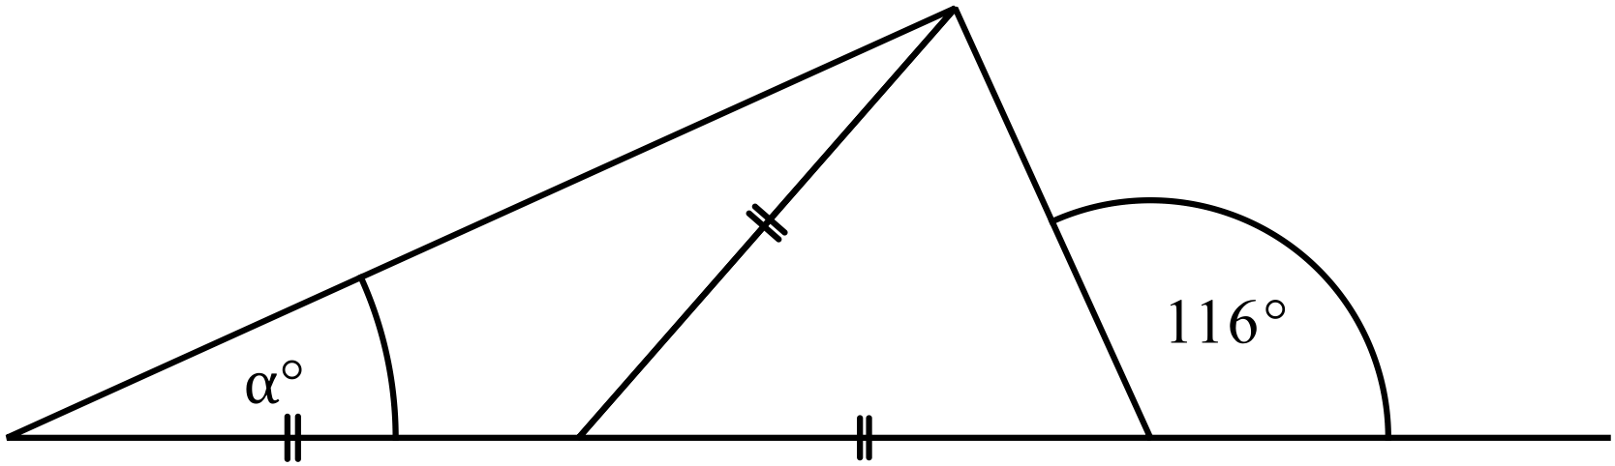

A. 16º B. 26º C. 32º D. 52º
Four years ago, Andrew purchased a printer for his business.
The purchase price was $36 000 and the depreciation rate over the time was 12% p.a.
What is the value of the printer now?
A. $18 720.00
B. $21 589.03
C. $21 902.40
D. $24 532.99
Expand and simplify 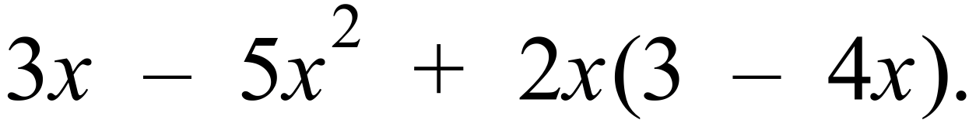

A. 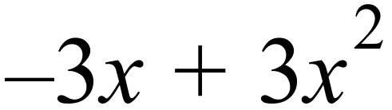
B. 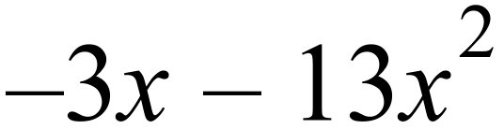
C. 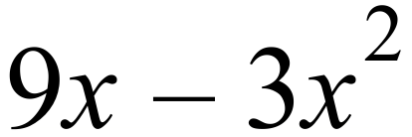
D. 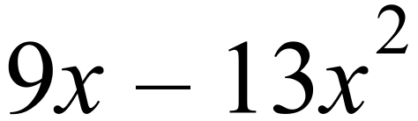
Which of these expressions is not a factor of 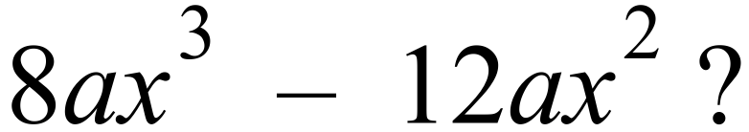

A. 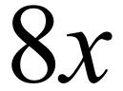 B. 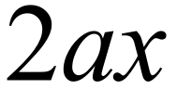 C. 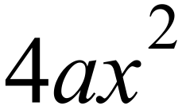 D. 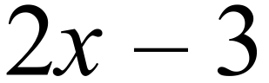
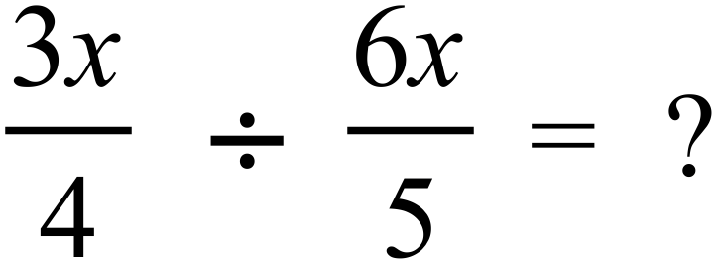

A. B. 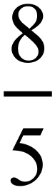 C. 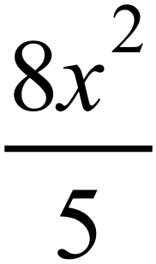 D. 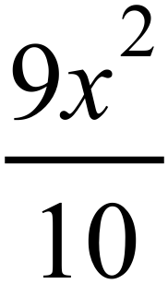
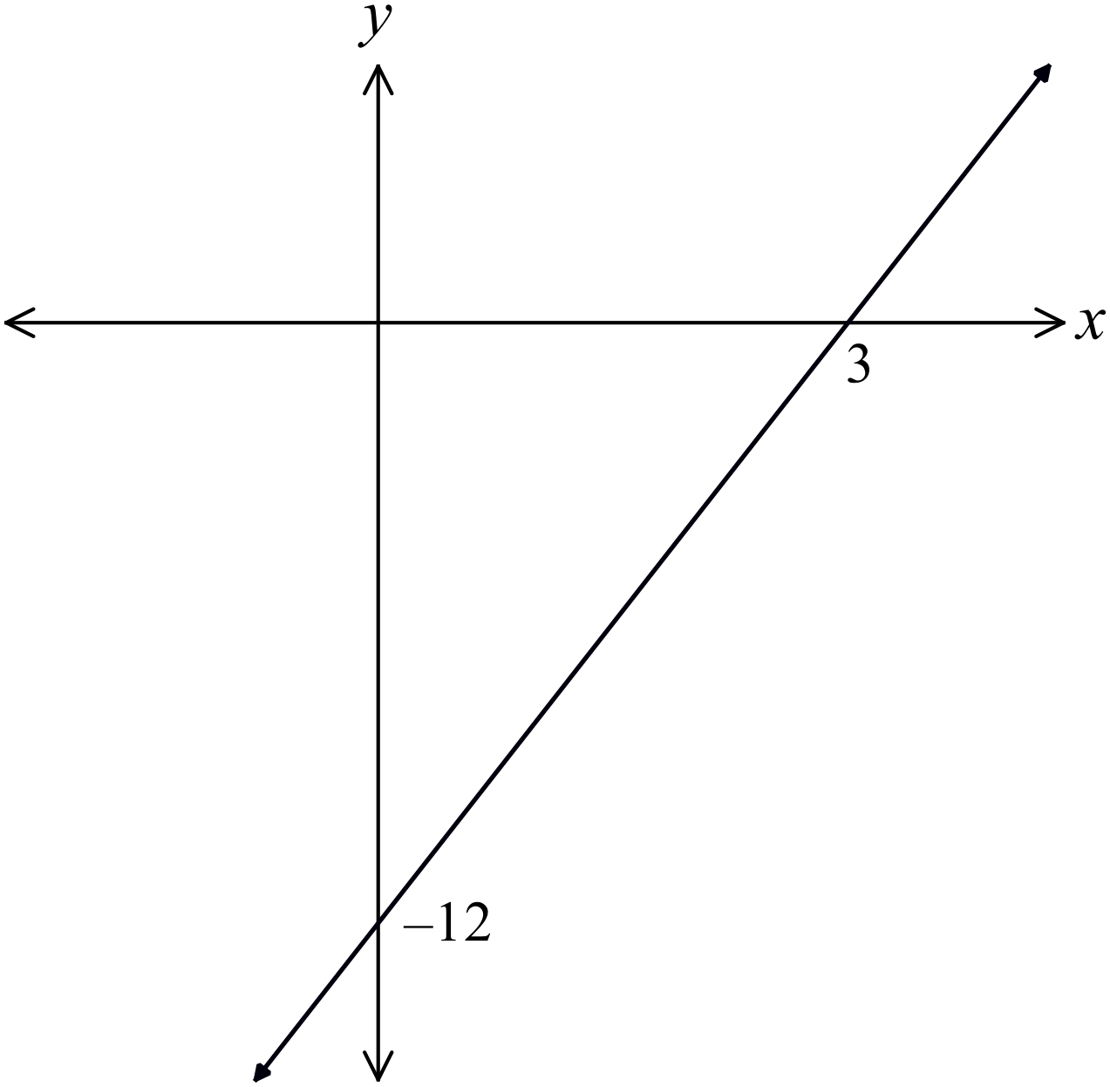What is the equation of the line shown on the number plane?

A. 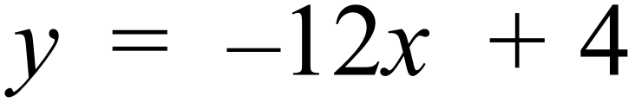
B. 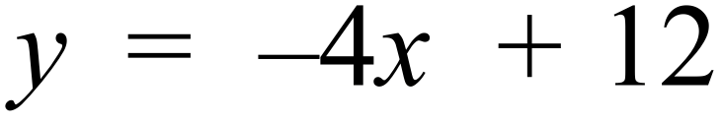
C. 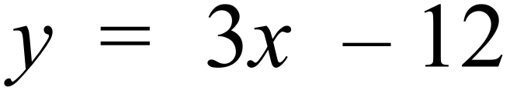
D. 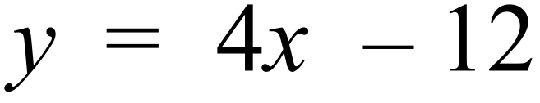

The mass of the Earth is estimated to be 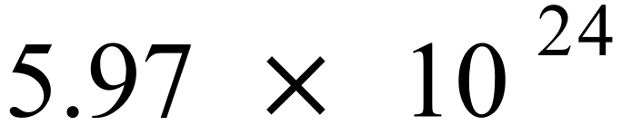 kg and that of Mars to be 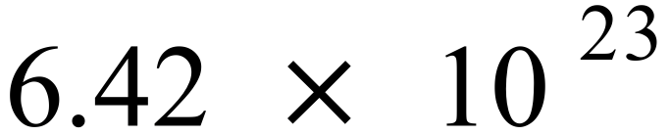 kg.
What percentage of the Earths mass is that of Mars?
(Answer correct to 3 significant figures)
A. 10.8% B. 108% C. 1 080% D. 10 800%
Which number line graph represents 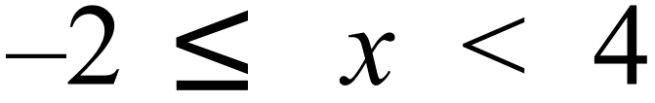 ?
A.
B.
C.
D.
Questions 62 and 63 refer to the following:
A television talent program gives contestants a total score out of 100.
The scores of 48 contestants are represented in the box and whisker plot below.
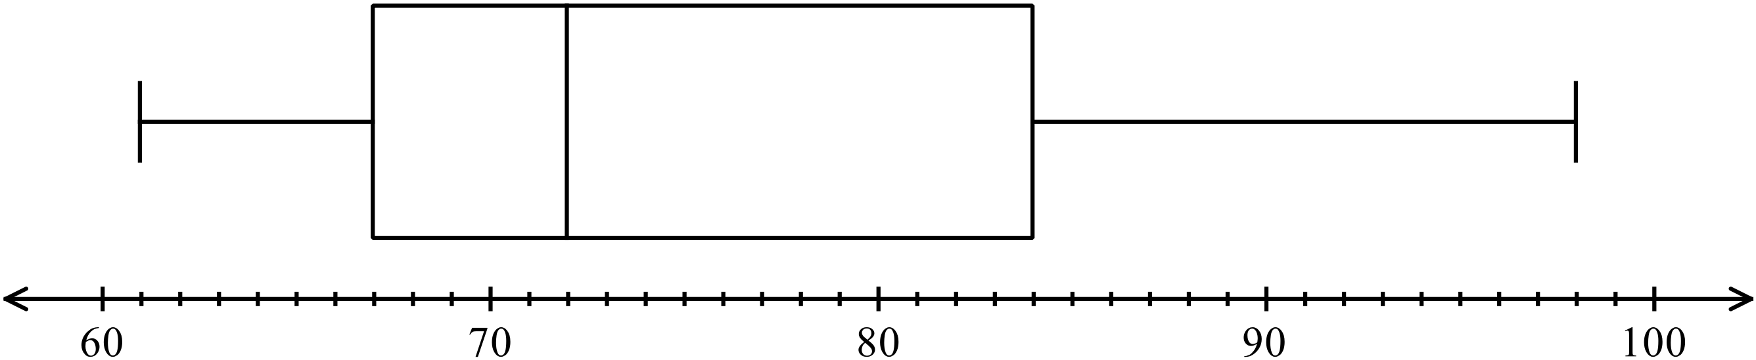

Based on the graph, which of these descriptions could be used to describe the shape of the distribution of scores?
A. The distribution of scores is bimodal in shape.
B. The distribution of scores is negatively skewed.
C. The distribution of scores is positively skewed.
D. The distribution of scores is symmetrical.
How many contestants had scores of 67 or more?
A. 12 B. 24 C. 31 D. 36
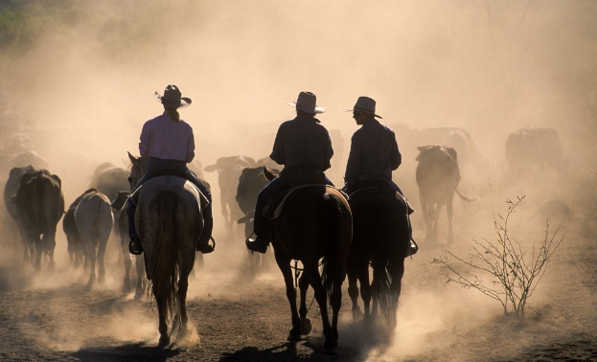
A group of drovers are taking a herd to fresh pasture.
The 250 cattle in the herd come from four stations.
The table shows the home station for the cattle.
Home Station | Number of Cattle
Aster Park | 80
Birch Downs | 65
Camelia Station | 42
Daffodil Estate | 63

If one of the cattle breaks free from the herd, what is the probability that it does not come from Birch Downs?
A. 0.26 B. 0.35 C. 0.74 D. 0.83
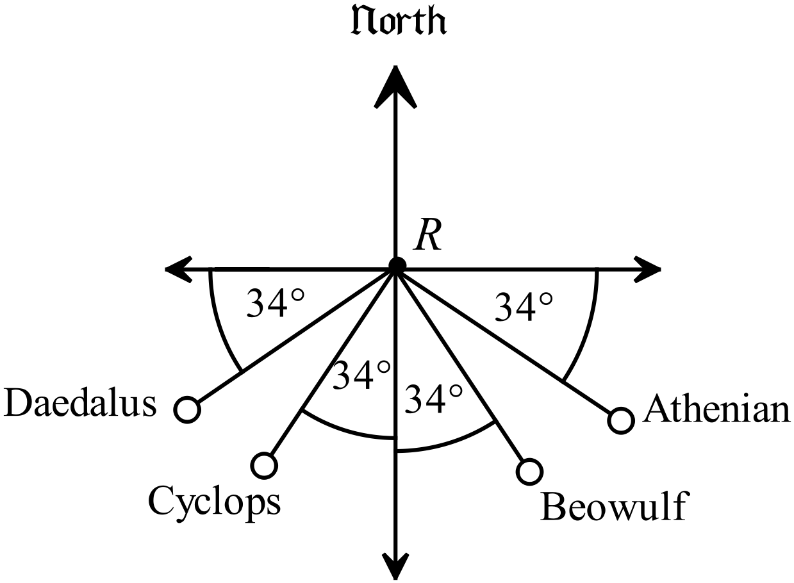Four boats are located by a radar station which is at the point R.
Their positions are shown on the diagram.
Which boat in on a bearing of 236º from R?

A. Athenian
B. Beowulf
C. Cyclops
D. Daedalus
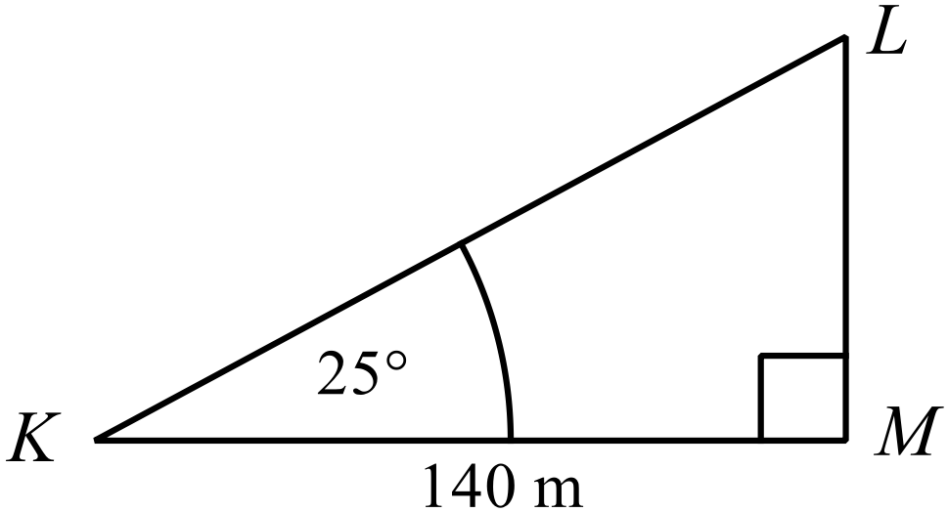In , KM = 140 m and 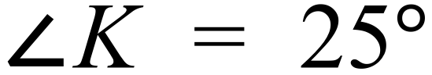.
What is the length of KL?
Answer to the nearest metre.
A. 154 m
B. 173 m
C. 300 m
D. 331 m
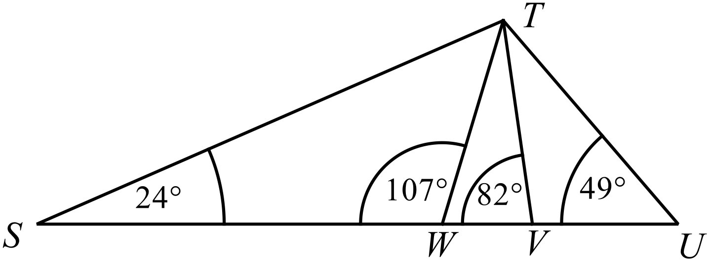Which triangle is similar to 
A. 
B. 
C. 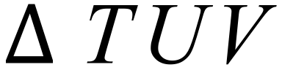
D. 
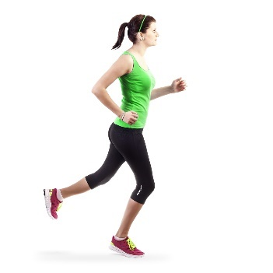
Louise runs 750 m in 3 minutes.
What is her speed in km/h?

A. 4.2 km/h
B. 7.5 km/h
C. 12 km/h
D. 15 km/h
Kristy borrows $30 000 and agrees to repay the principal and interest at the end of four years.
Interest is calculated at 7.2% p.a., compounded monthly.
How much must she repay?
A. $37 874.31
B. $38 640.00
C. $39 978.30
D. $42 332.67
Which of these lines would be parallel to the line 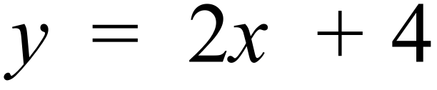 and pass through the point (2, –6).
A. 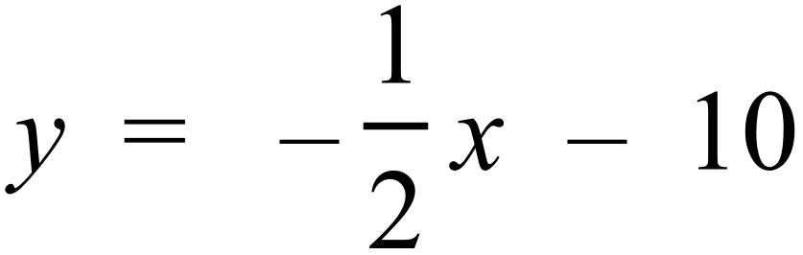
B. 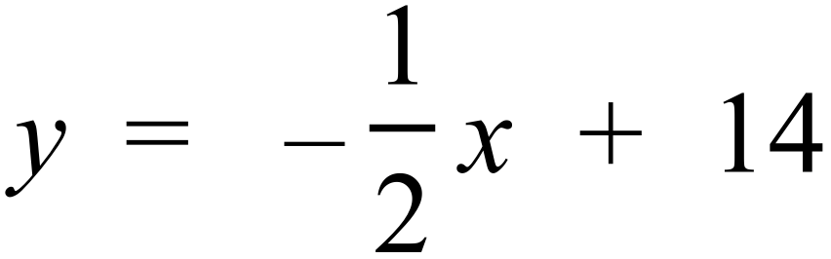
C. 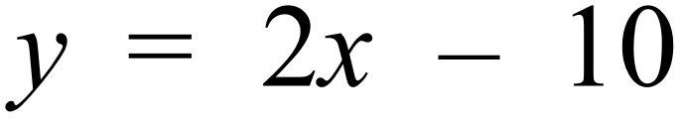
D. 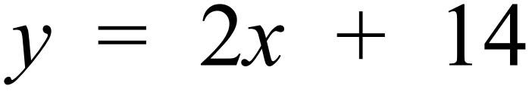
Which expression is equal to 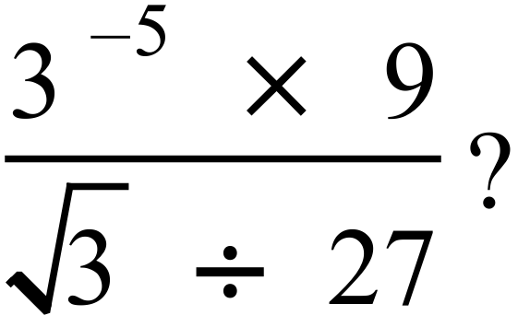
A. 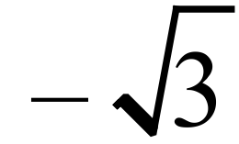 B. 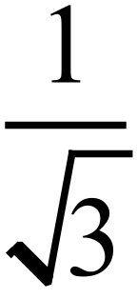 C. 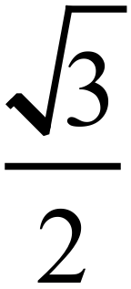 D. 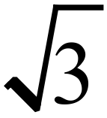
Questions 47 and 48 refer to the following:
The scatterplot compares the age of the entrant with the number of mistakes they made in an essay competition.
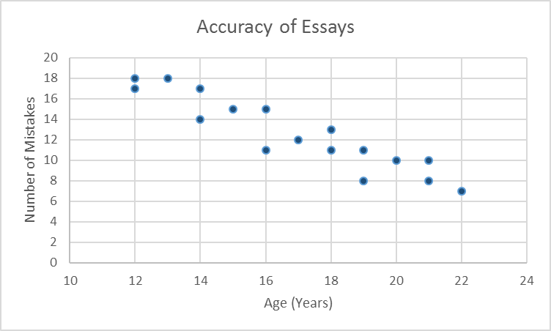

What was the mean number of mistakes for those aged 16 and under?

A. 14 B. 14.5 C. 15.4 D. 15.625
Which best describes the relationship shown on the scatter plot?
A. There is a strong negative relationship between age and number mistakes.
B. There is a weak negative relationship between age and number mistakes.
C. There is a strong positive relationship between age and number mistakes.
D. There is no relationship between age and number of mistakes.
Which equation could possibly describe the curve shown on the number plane?
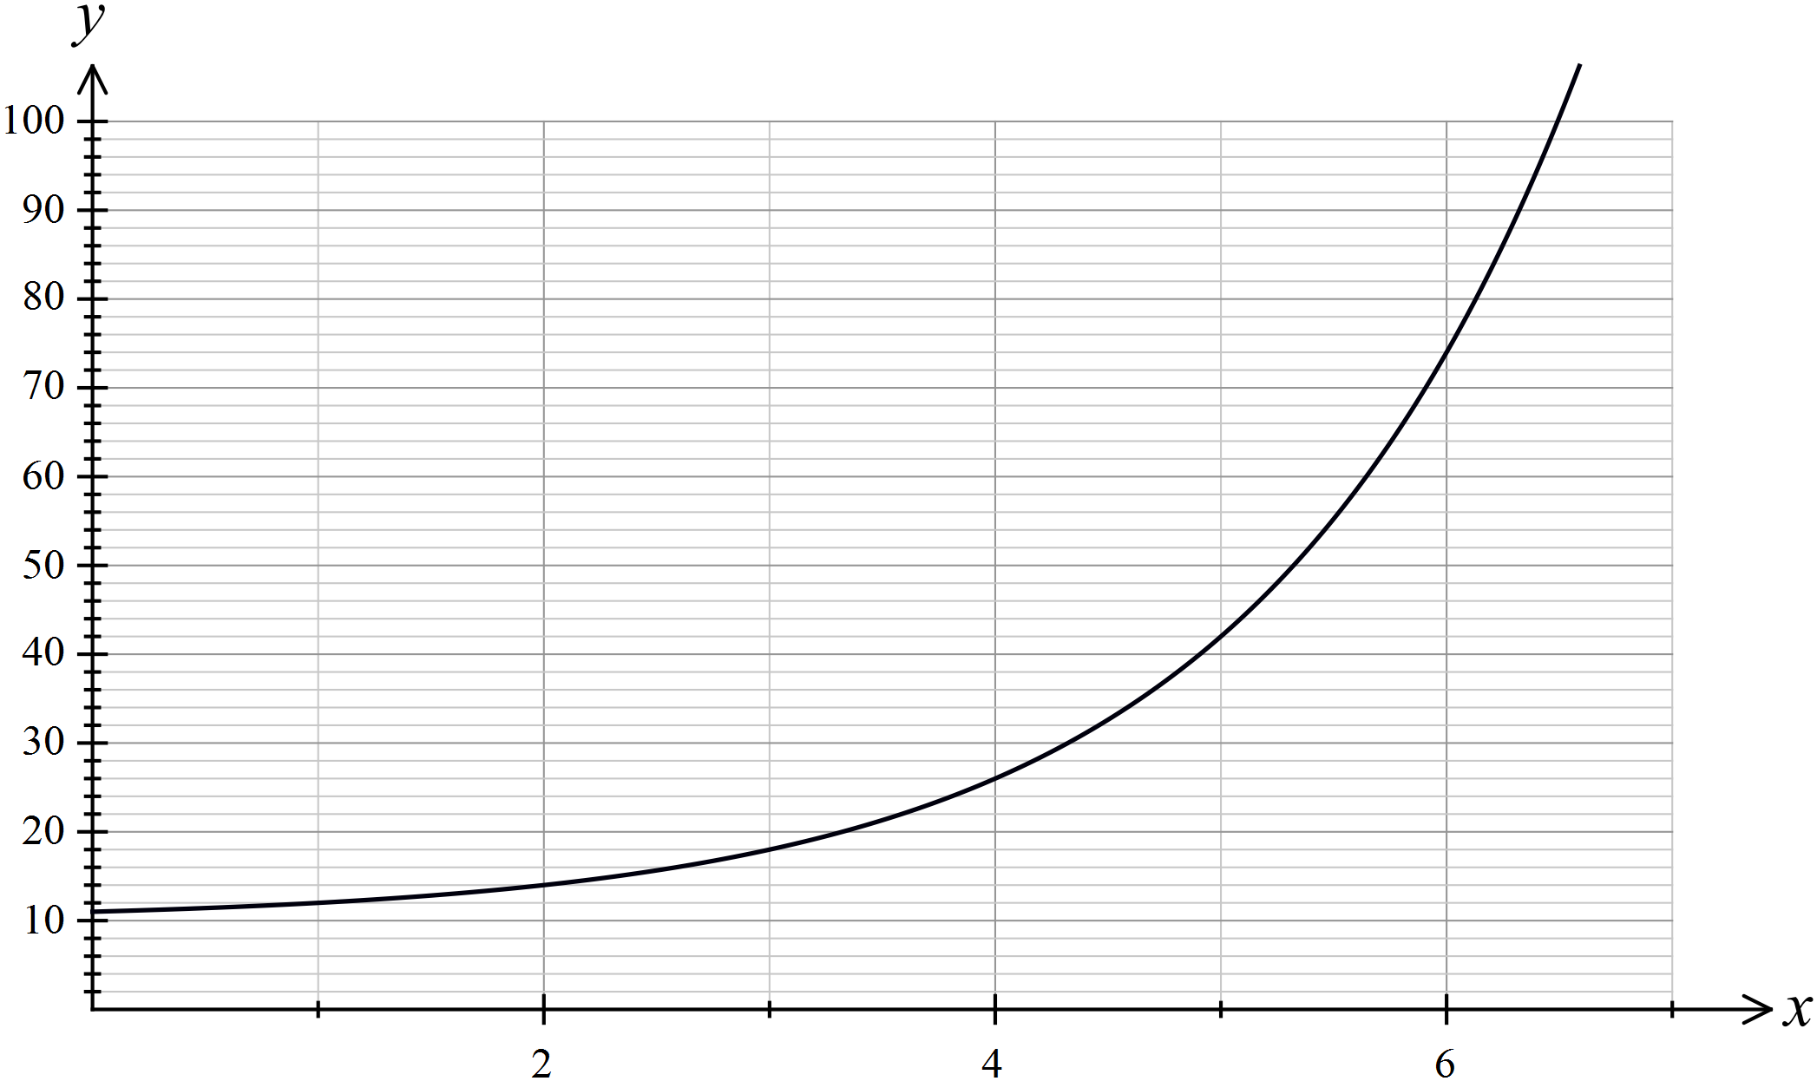

A. 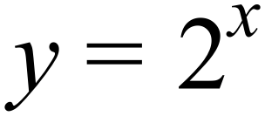
B. 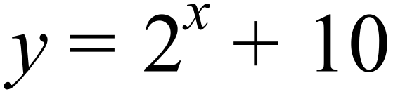
C. 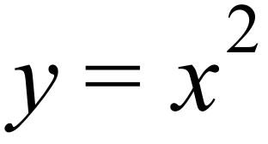
D. 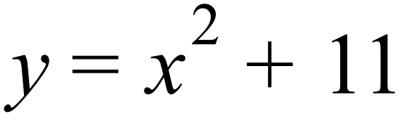
Which of the equations below would represent a parabola on the number plane?

A. 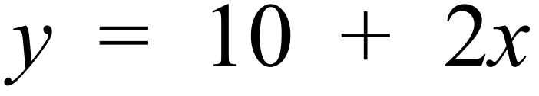
B. 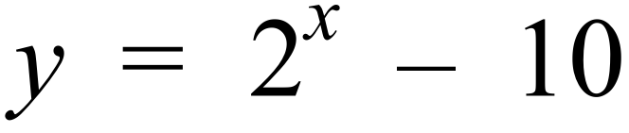
C. 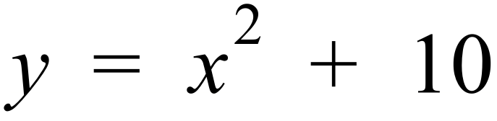
D. 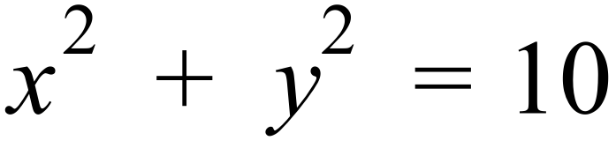
What is the equation of the line on the number plane which is parallel to the line 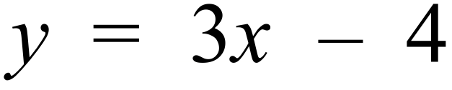 and crosses the y axis at –5?

A. 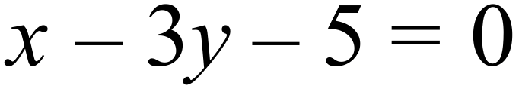
B. 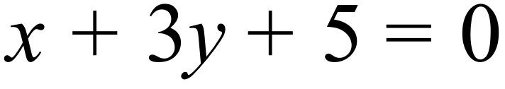
C. 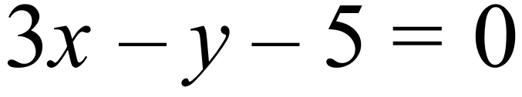
D. 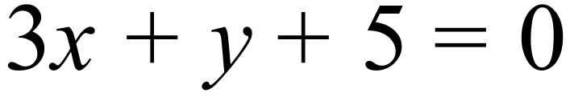
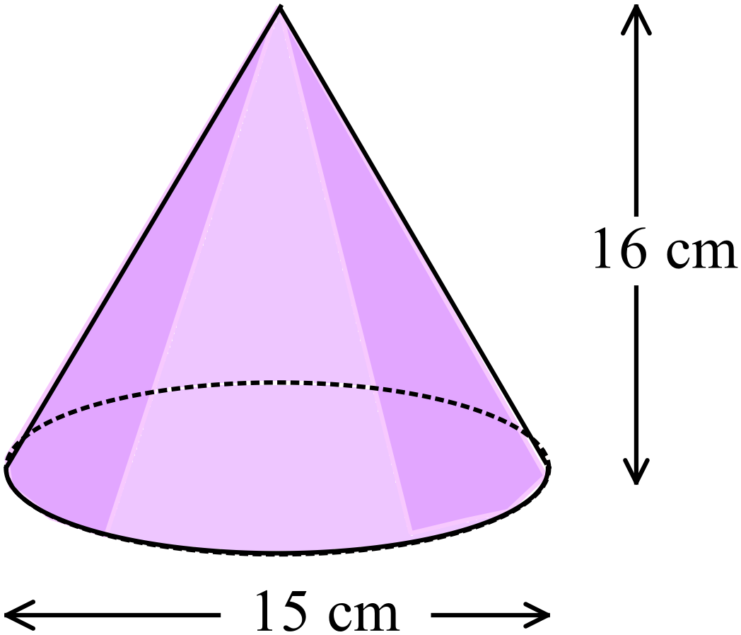What is the volume of this cone?

A. 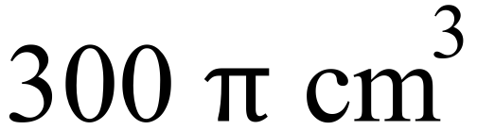
B. 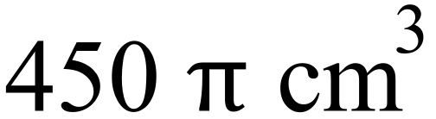
C. 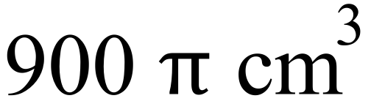
D. 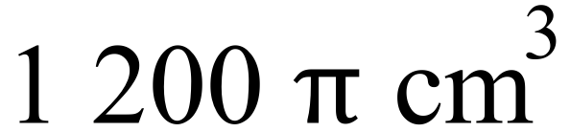

Solve 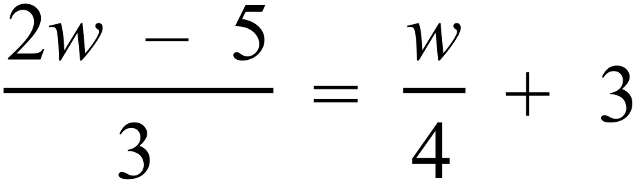 .

A. 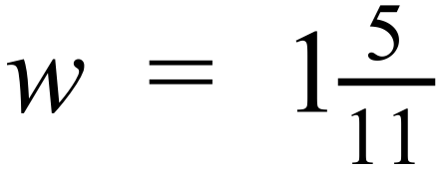 B. 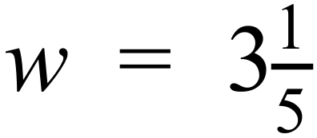 C. 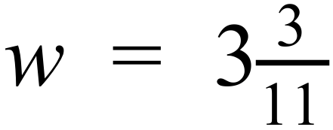 D. 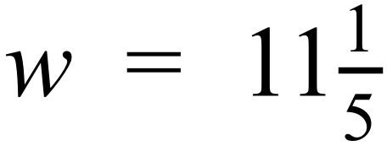

The times (in hours to 2 decimal places) to complete a 20 km walk by 5 men are given below.
1.44, 1.38, 1.36, 1.55, 1.47
What is the standard deviation of the times?

A. 0.068 B. 0.075 C. 0.140 D. 1.44
Simplify 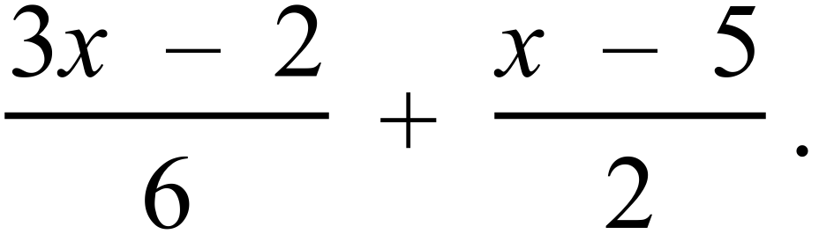
A. 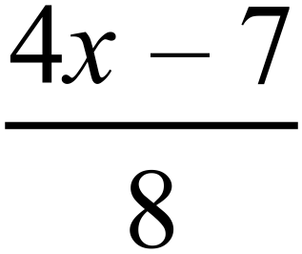 B. 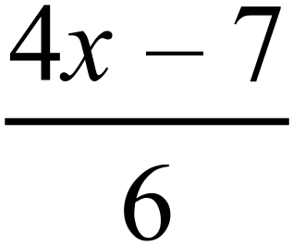 C. 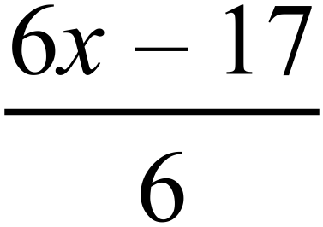 D. 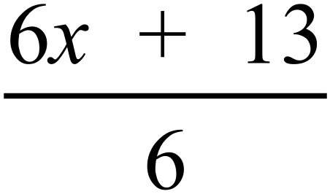
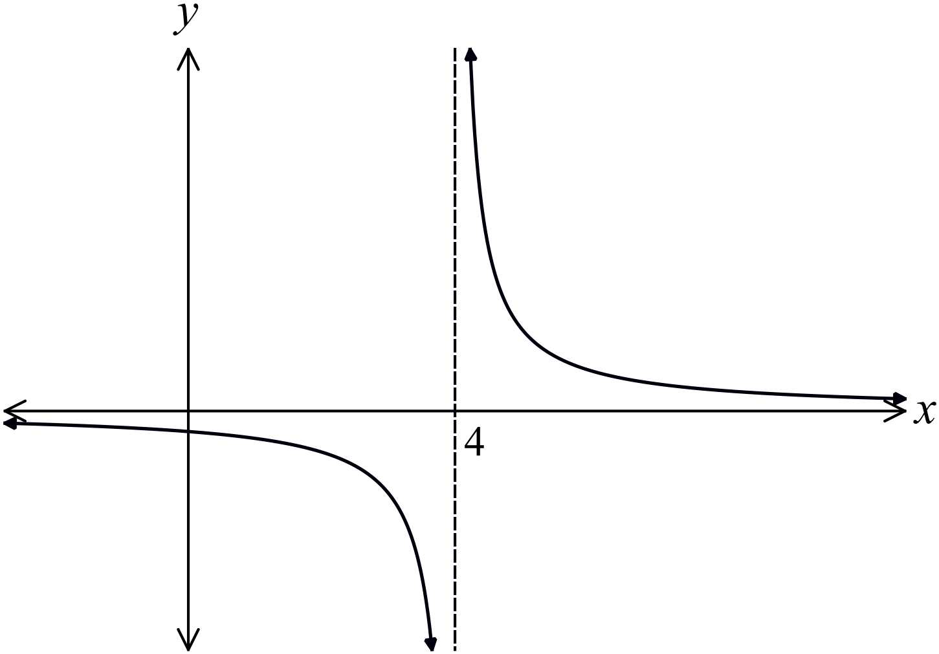Which equation could describe this curve shown on the number plane.

A. 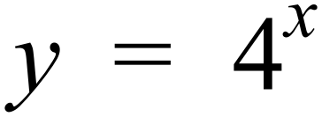
B. 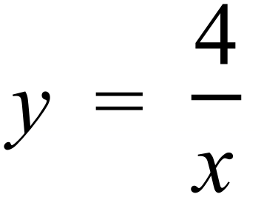
C. 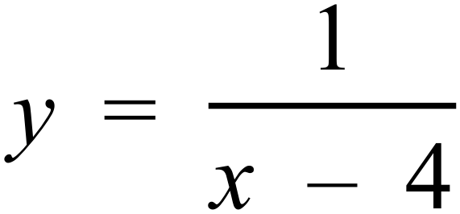
D. 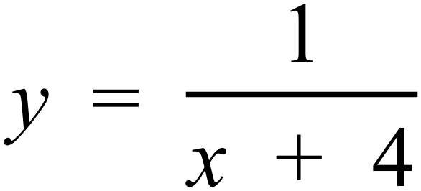

Solve 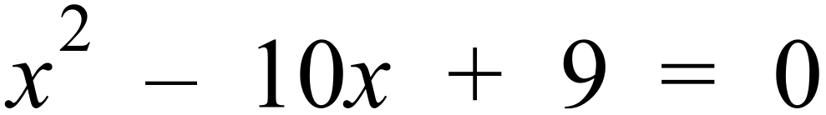 .
A.
B.
C.
D. 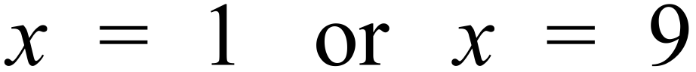
Damien was asked to solve the pair of simultaneous equations below.
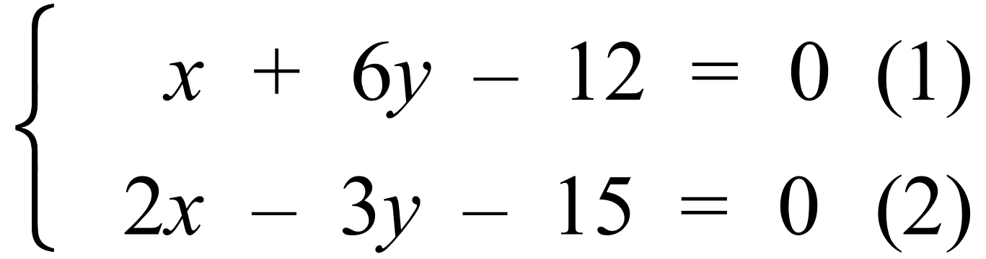
Which would not be appropriate as a first step in the solution?
A. Make x the subject of equation (1) to use the substitution method.
B. Make y the subject of equation (2) to use the substitution method.
C. Multiply equation (1) by 2 to use the elimination method.
D. Multiply equation (2) by 2 to use the elimination method.
A car accelerates from a stationary position.
At first, the rate of acceleration increases, then decreases till the car reaches it cruising speed.
Which graph could represent its speed compared to time?
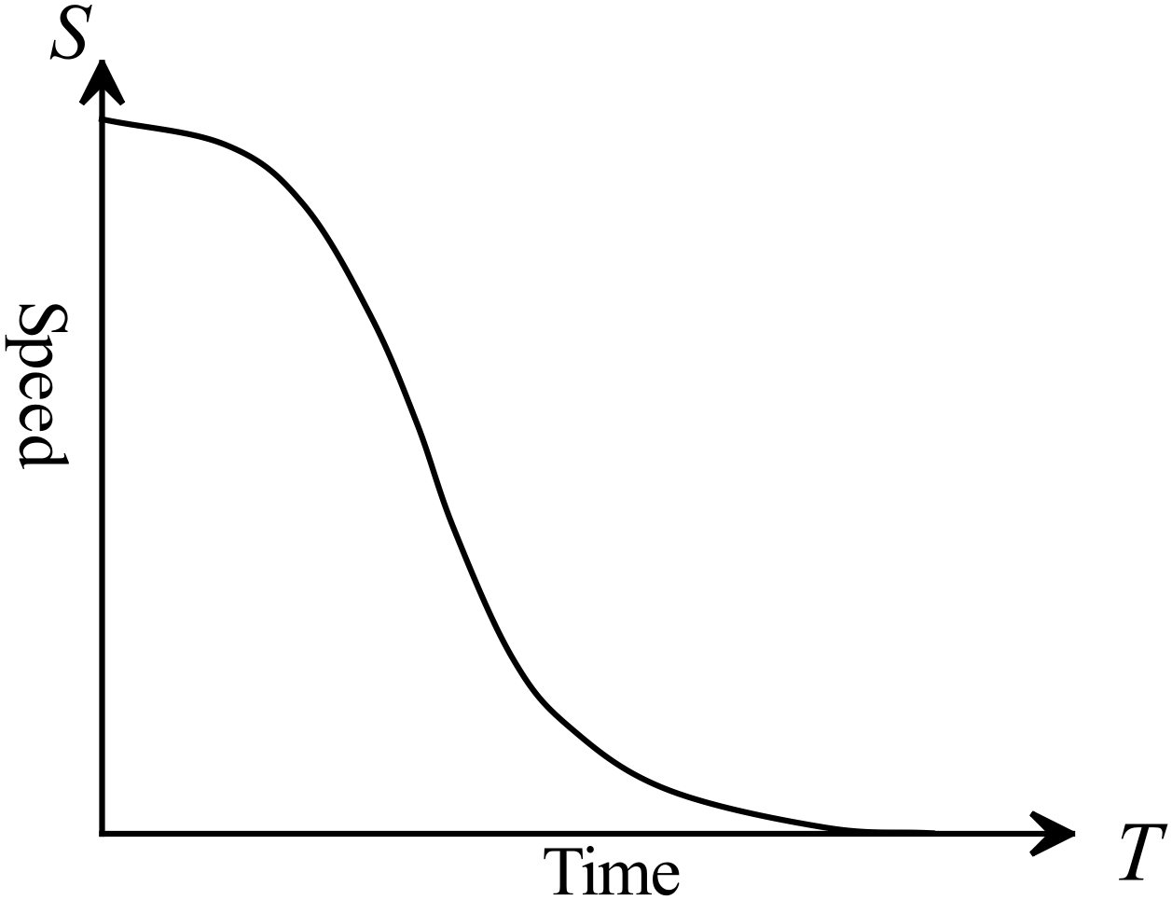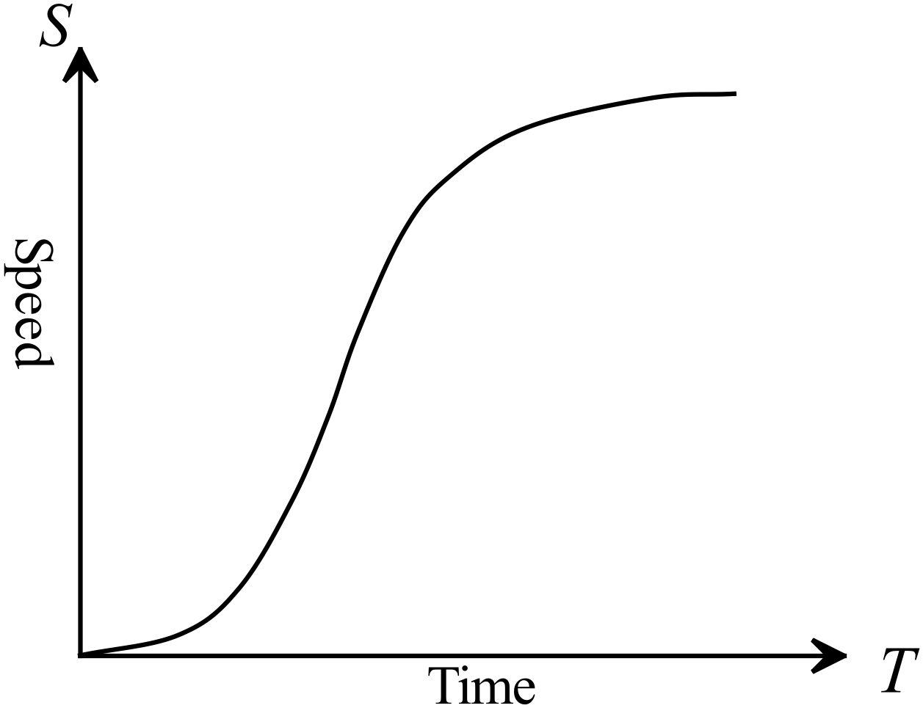 A. B.

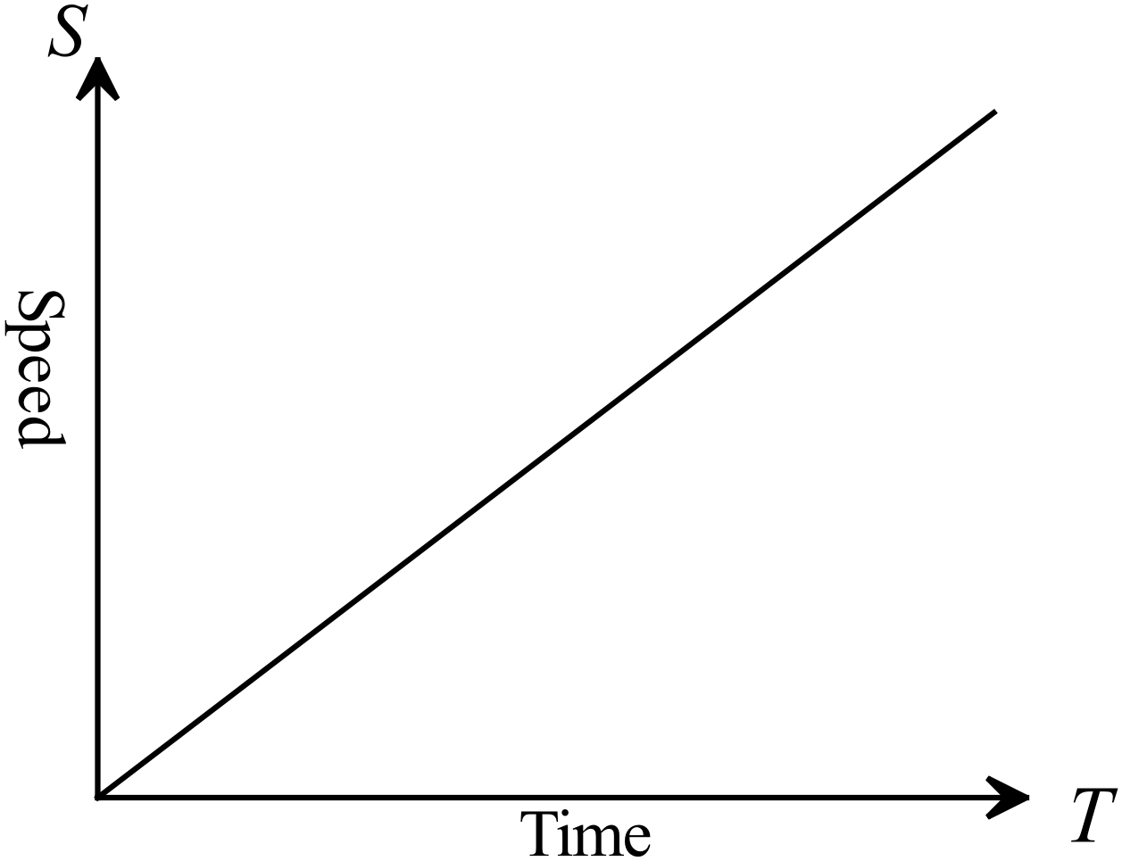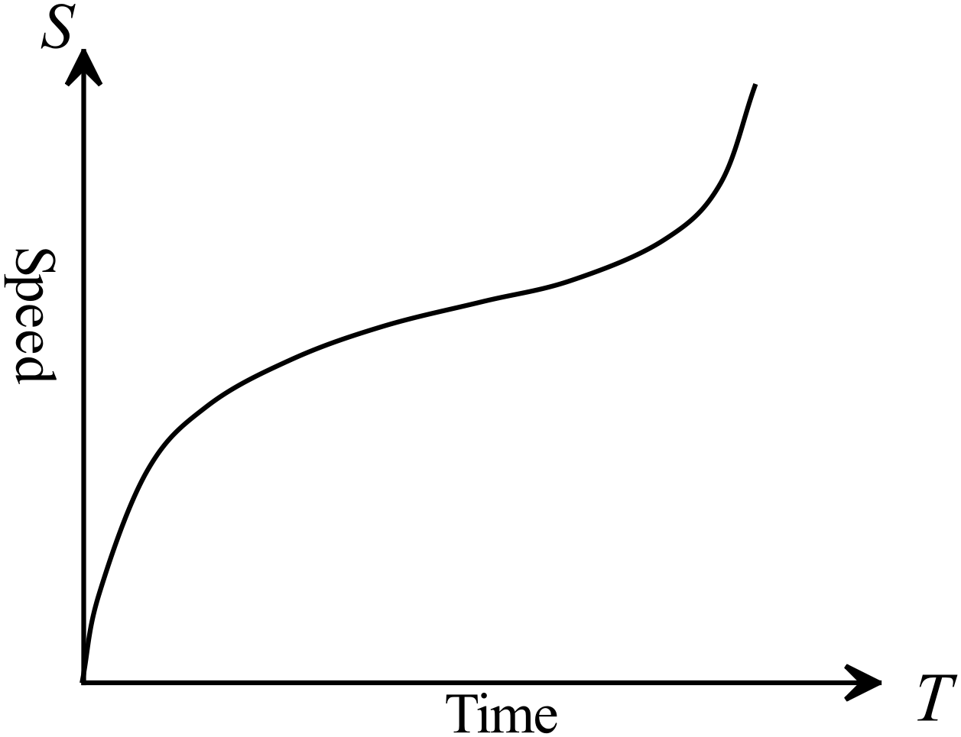 C. D.

Express 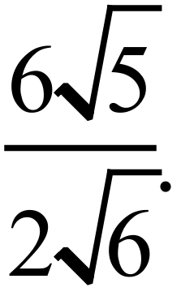 as a fraction with a rational denominator.

A. 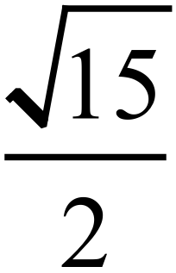
B. 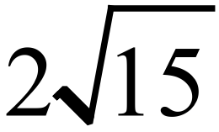
C. 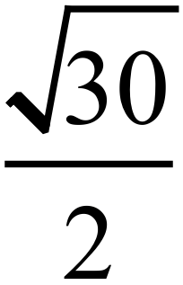
D. 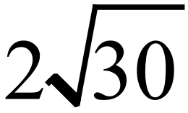
A soccer ball is a sphere with circumference of 70 cm.
What is the surface area of the ball?

A. 1 560 cm² B. 6 250 cm² C. 15 390 cm² D. 61 580 cm²
Rewrite the equation 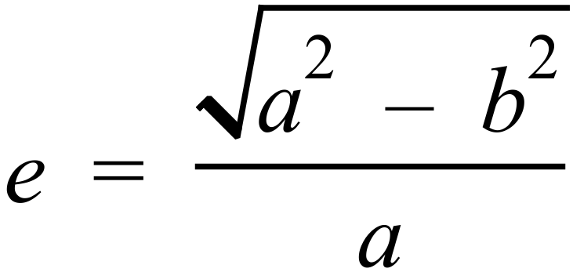, so that 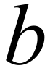 is the subject.
A. 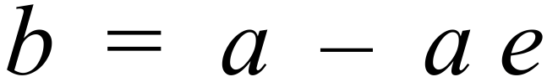
B. 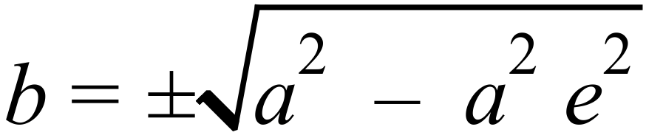
C. 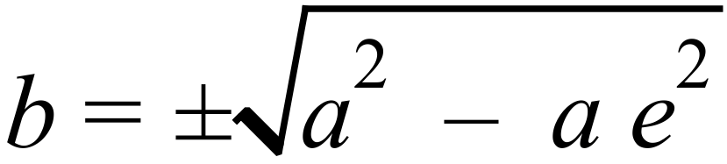
D. 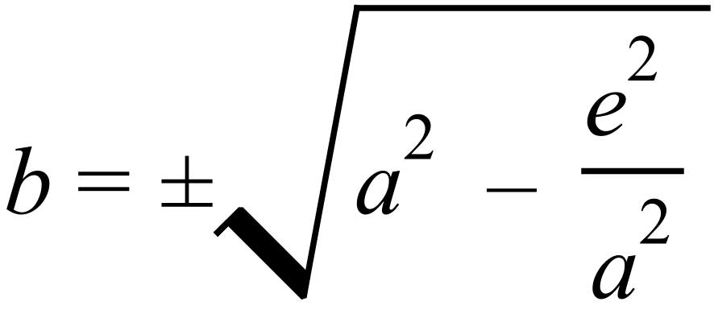
Expand 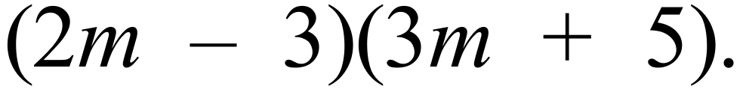
A. 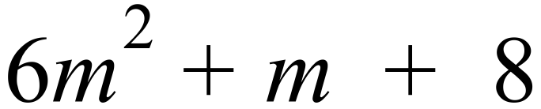
B. 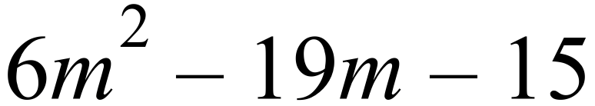
C. 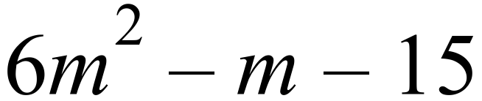
D. 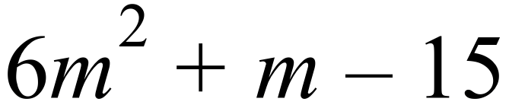
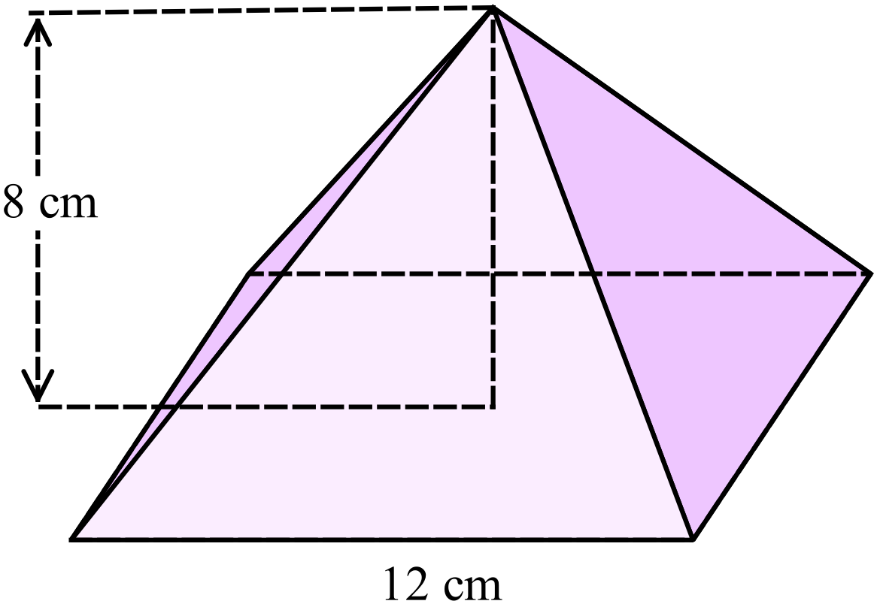A square pyramid has base edges 12 cm long and a perpendicular height of 8 cm.
Calculate the surface area of the pyramid.

A. 240 cm²
B. 288 cm²
C. 336 cm²
D. 384 cm²

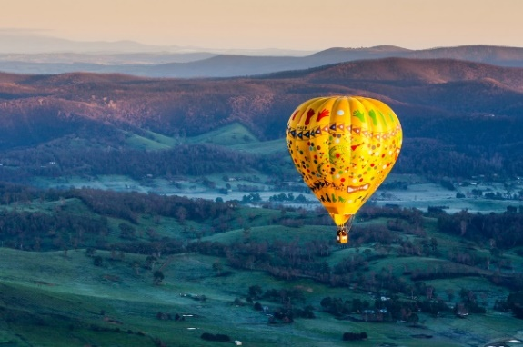
A hot air balloon is used for morning and afternoon flights.
The duration of the two flights are recorded over a two-week period and an analysis is shown below.
Time of take off | Mean length of flight  (minutes) | Standard deviation
Morning | 24.25 | 0.85
Afternoon | 21.65 | 1.22
Which statement is correct?
A. The morning flights were shorter on average.
B. The morning flights had more variation in their duration.
C. The afternoon flights were longer on average.
D. The afternoon flights had more variation in their duration.
In the triangle ABC, AC = 25 cm, BC = 19 cm and 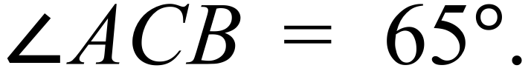
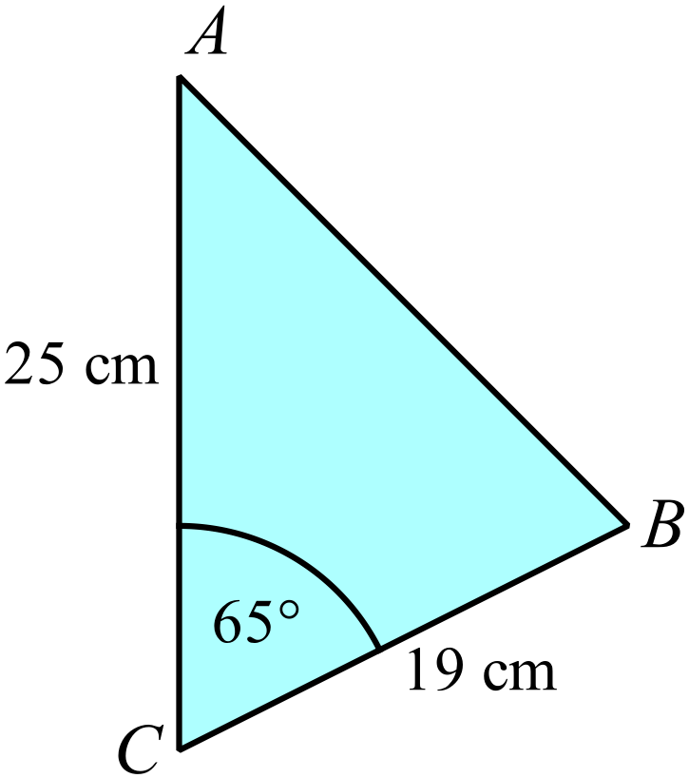Find the length of AB.

A. 14.6 cm
B. 24.2 cm
C. 84.4 cm
D. 524.1 cm
In
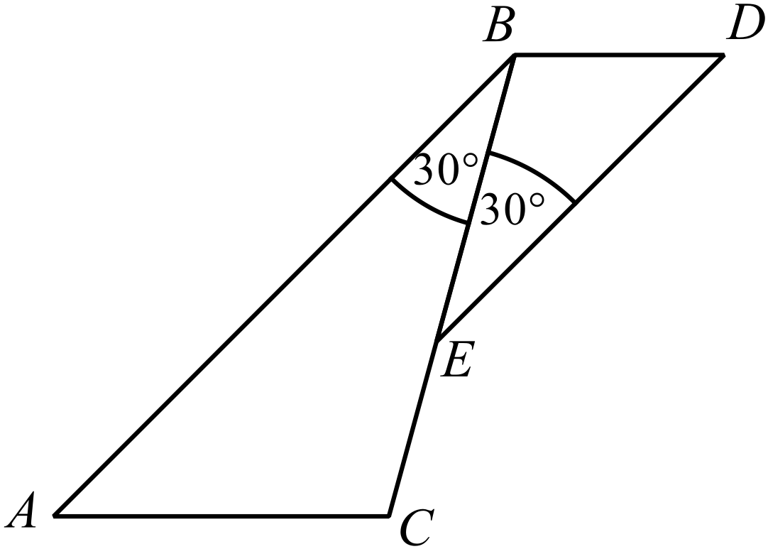

Which additional piece of information would be sufficient to prove that 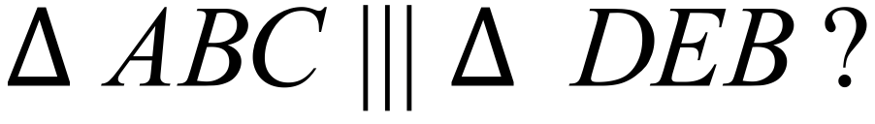
A.  B.  C.  D. 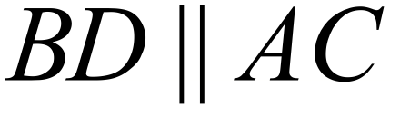
Andy rented a vehicle and he was randomly allocated a style and colour.
The company had four styles of vehicle and four colours, as indicated by the table below.

Colour | Style
Colour | Sedan | Hatch | Ute | Coupe
Red | RS | RH | RU | RC
Blue | BS | BH | BU | BC
White | WS | WH | WU | WC
Green | GS | GH | GU | GC
If there was only one vehicle in each style and colour, what is the probability that he was allocated a vehicle which was a coupe or red, but not both?
A. 0.25 B. 0.3125 C. 0.375 D. 0.4375
What is the equation of the line which passes through the points (2, –1) and (–2, 7) on the number plane?
A. 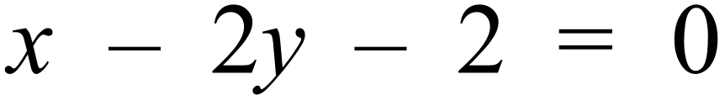
B. 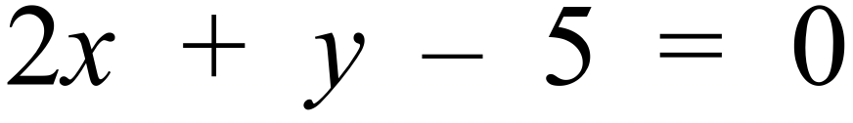
C. 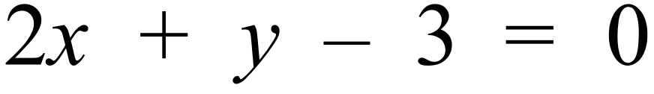
D. 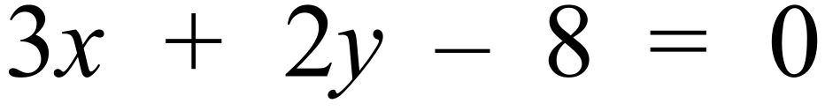
In the diagram below, O is the centre of the circle, EG is a diameter and FH is a chord which intersects EG at D.
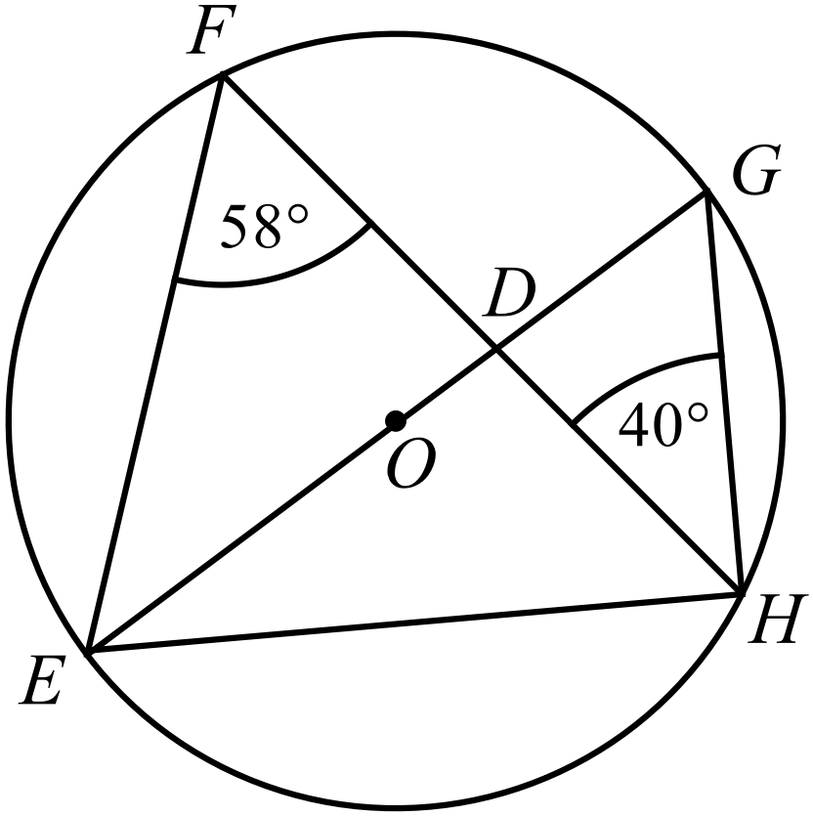

What is the size of 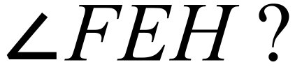
A. 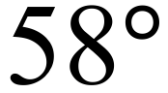 B. 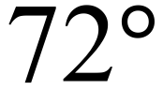 C. 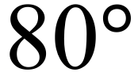 D. 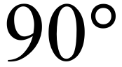
What is the value of 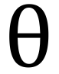 (to the nearest degree) in the diagram below?
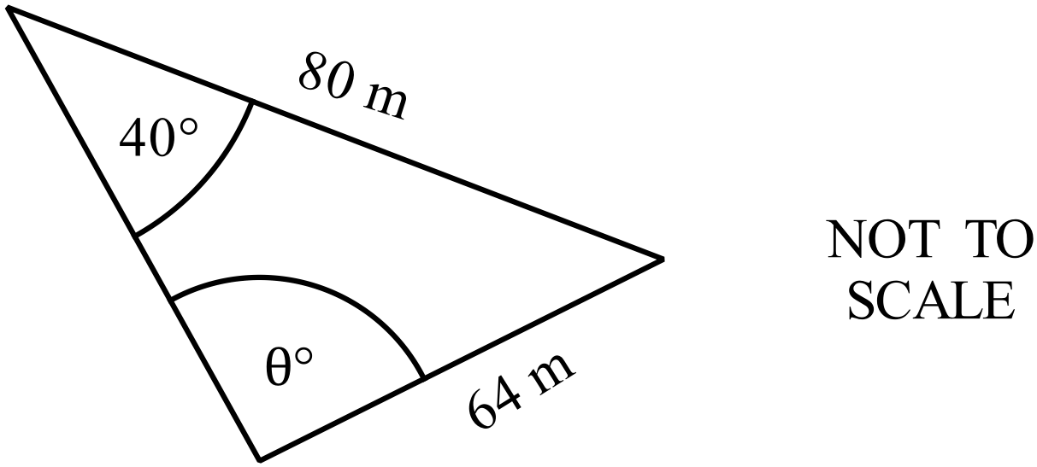

A. 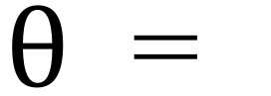 31 B. 51 C. 52 D. 53
Which of these lines is perpendicular to 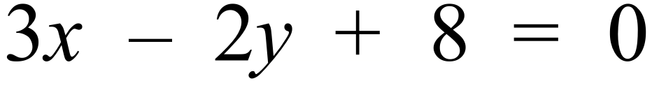 and passes through the point (4, 5)?
A. 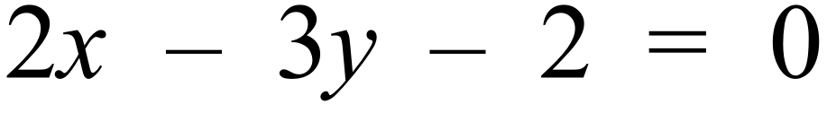
B. 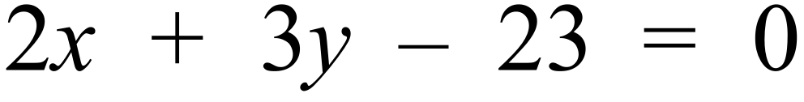
C. 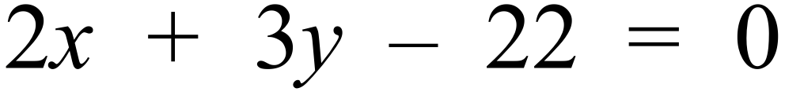
D. 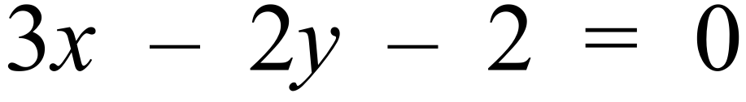
The Venn diagram shows the results of a survey of 50 people who were asked their three favourite activities.
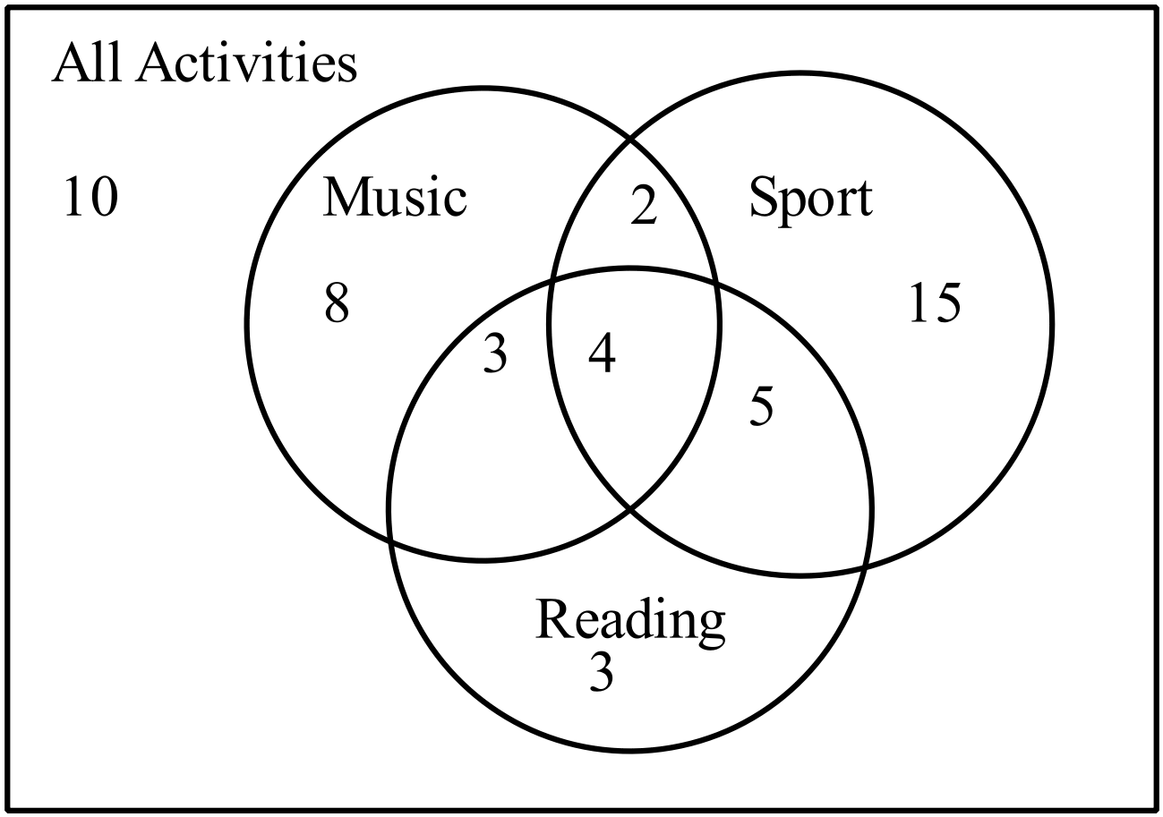

A person who listed Sport as one of their activities is chosen at random from the survey group.
What is the probability that they also listed Reading and Music?
A. 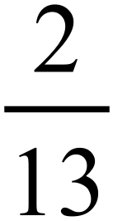 B. 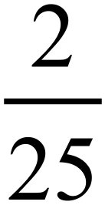 C. 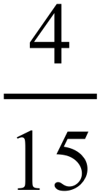 D. 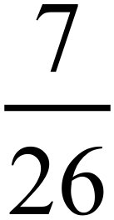
What are the solutions to 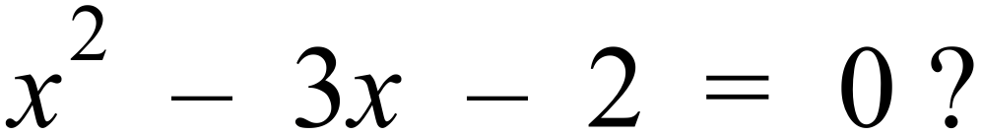
A.
B. 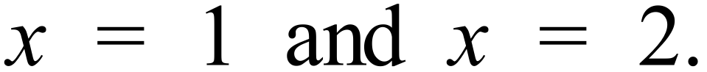
C. 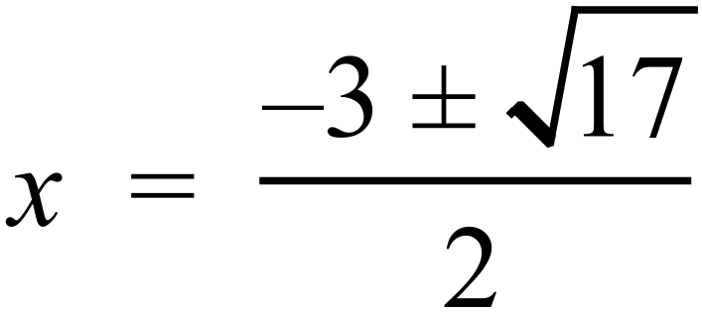
D. 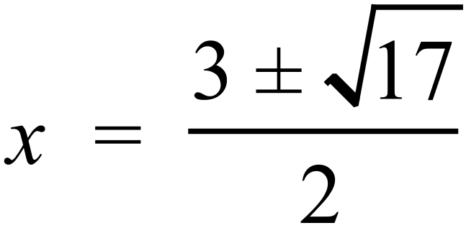
The curve shown on the number plane below has equation 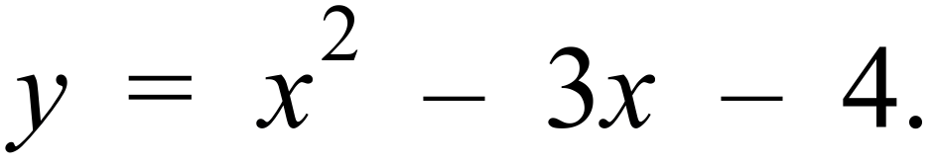
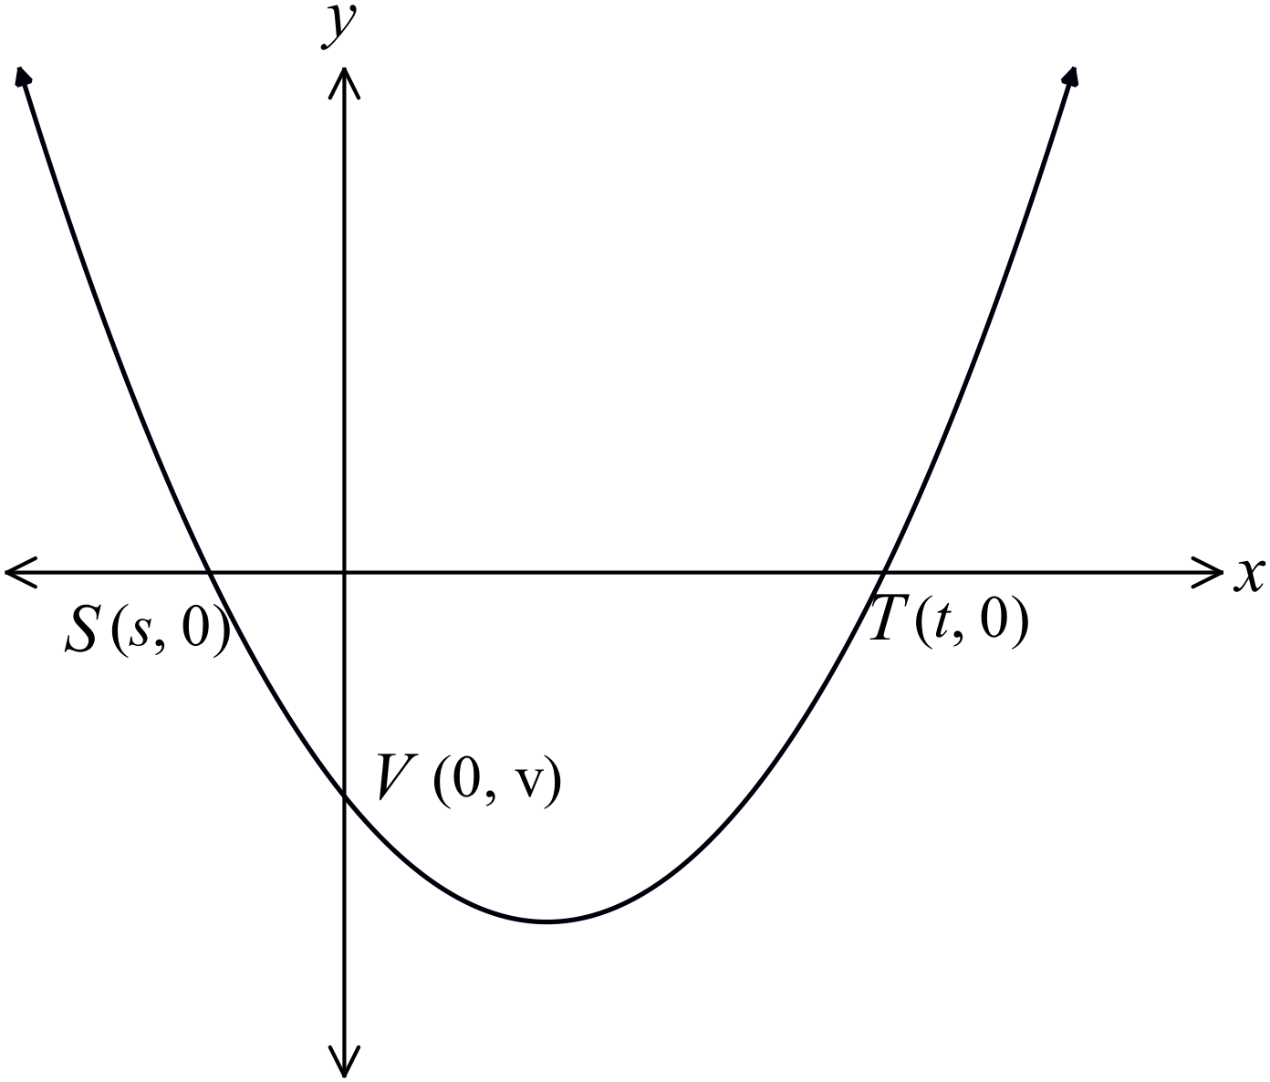The points of intersection of the curve with the axes are labelled S (s, 0), T (t, 0) and V (0, v).

What are the values of s, t and v?
A.
B.
C.
D.
End of Section 2 - Part A

School Name  Yearly Examination |  | Advanced Mathematics Course  2016
Section 2  Part B  Longer Answer Section |  | Name : _______________________________
 |  | Class/Teacher___________________________
Write all working and answers in the spaces provided on this examination paper.
Calculators are allowed for this section.

 |  | Marks
76. | Two groups of volunteers took a test where they were shown seven objects in ten seconds.  It was then recorded how many of the objects they could recall after a minute.  The statistical measures for Group A and the raw data for Group B are shown below.
  Group A |  |  | Group B
   |  |  |  | Score (x) | Frequency  (f) | Cumulative  Frequency
  Number (n) = |  | 25 |  | Score (x) | Frequency  (f) | Cumulative  Frequency
  Mean ( 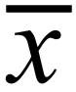 ) = |  | 5.03 |  | 3 | 5 | 5
  Median = |  | 5 |  | 4 | 6 | 11
  Standard deviation (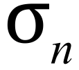) = |  | 0.45 |  | 5 | 3 | 14
   |  |  |  | 6 | 7 | 21
   |  |  |  | 7 | 5 | 26
 | - Complete the statistical measures for Group B below. | 2
  Number (n) =
  Mean ( ) =
  Median =
  Standard deviation () =
 | - Use the statistical measures to compare the performance of the two groups on the test. Your answer should be in terms of central tendency and spread.  ………………………………………………………………………………………..  ………………………………………………………………………………………..  ……………………………………………………………………………………….. | 1
77. | - Factorise 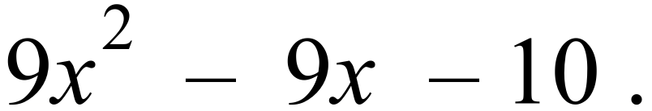  ………………………………………………………………………………………..  ……………………………………………………………………………………….. | 1
 | - Solve simultaneously:  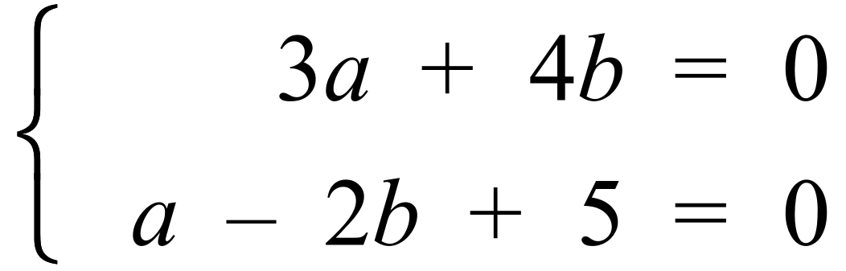  ………………………………………………………………………………………..  ………………………………………………………………………………………..  ………………………………………………………………………………………..  ………………………………………………………………………………………..  ……………………………………………………………………………………….. | 2
78. | - Re-write the equation 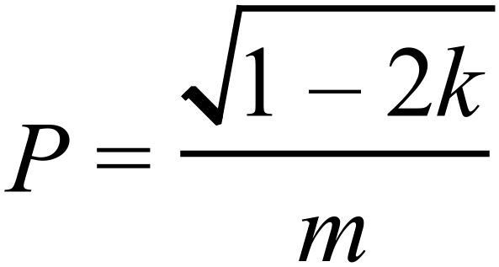 with k as the subject.  ………………………………………………………………………………………..  ………………………………………………………………………………………..  ……………………………………………………………………………………….. | 1
 | - Express 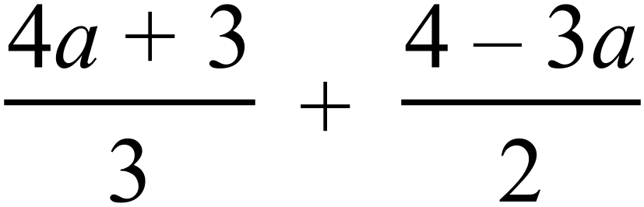 as a single fraction in simplest form.  ………………………………………………………………………………………..  ………………………………………………………………………………………..  ………………………………………………………………………………………..  ………………………………………………………………………………………..  ………………………………………………………………………………………..  ……………………………………………………………………………………….. | 2
79. | The points A, B and C lie on the circumference of a circle, whose centre is O, such that BC is a diameter of the circle.  DC is a tangent to the circle, hence 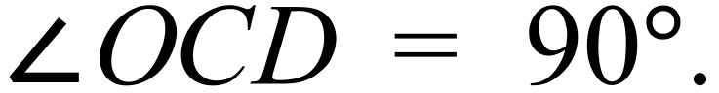 .  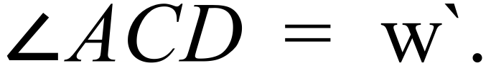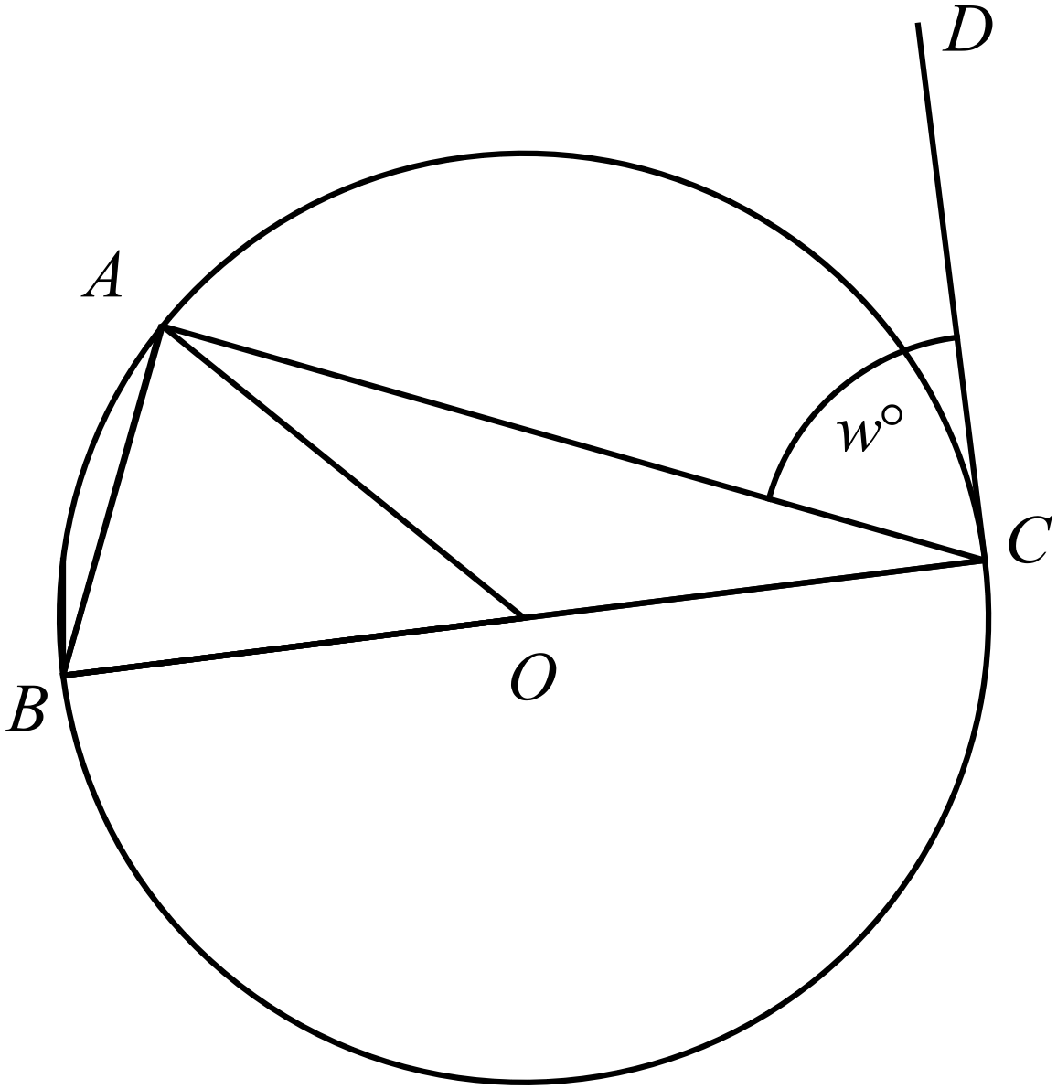  Prove the property that:  “The angle between a tangent and a chord, at the point of contact, is equal to the angle in the alternate segment.”  i.e. Prove that  ………………………………………………………………………………………..  ………………………………………………………………………………………..  ………………………………………………………………………………………..  ………………………………………………………………………………………..  ………………………………………………………………………………………..  ………………………………………………………………………………………..  ……………………………………………………………………………………….. | 3
80. | Airfield A is located 16.5 km due north of airfield B as shown on the diagram.  Two planes leave the two airfields and fly to a third airfield S.  The plane from A flies on a bearing of 068º and that from B on a bearing 038º.  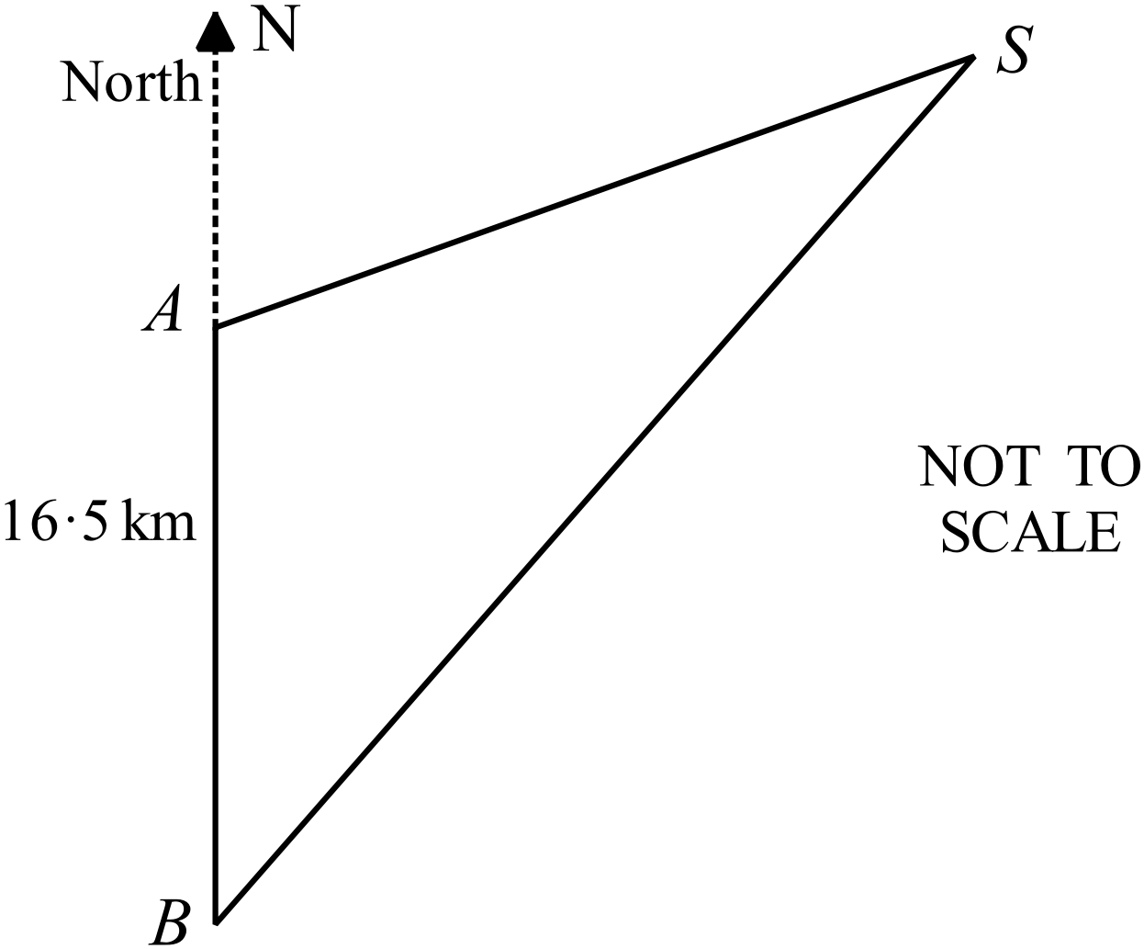
 | - Calculate the size of 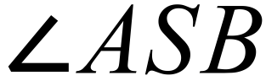 on the diagram.  ………………………………………………………………………………………..  ……………………………………………………………………………………….. | 1
 | - Show by calculation that the distance SB is 30.6 km (correct to 3 sig. fig.).  ………………………………………………………………………………………..  ………………………………………………………………………………………..  ………………………………………………………………………………………..  ……………………………………………………………………………………….. | 1
 | - Find the area of the triangle ABS.  ………………………………………………………………………………………..  ………………………………………………………………………………………..  ……………………………………………………………………………………….. | 1
81. | 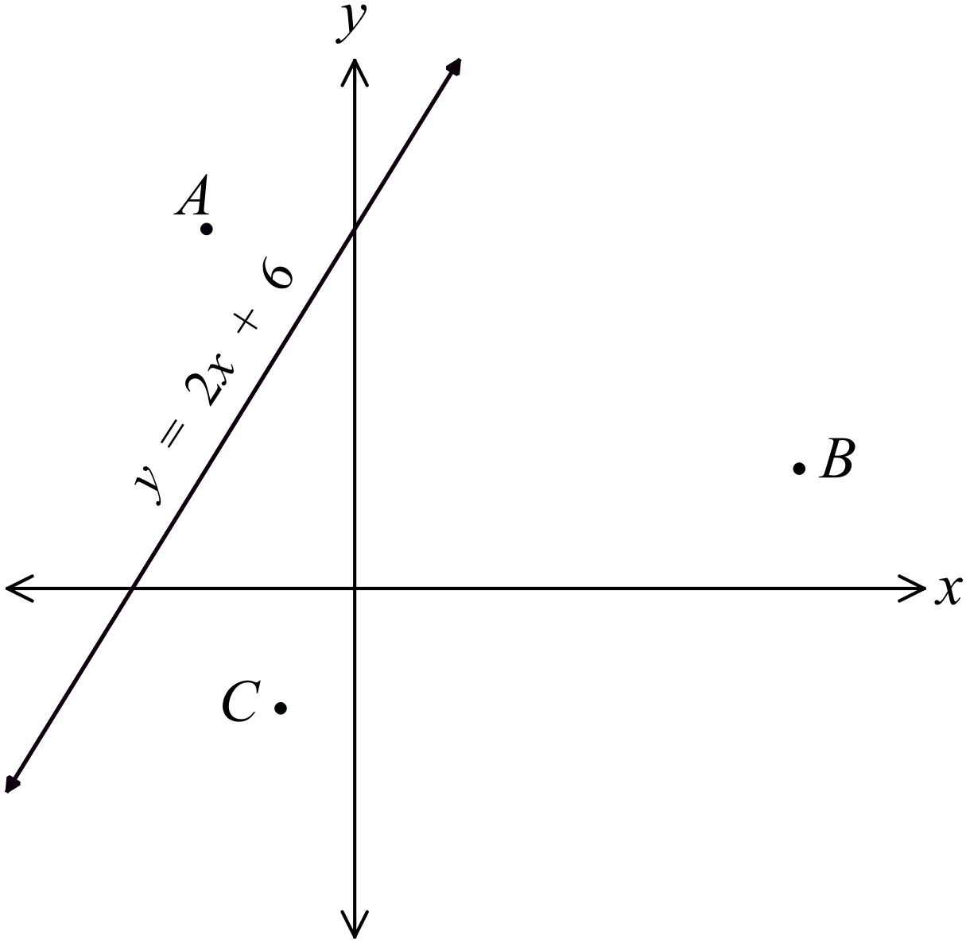The number plane below shows the points and the line 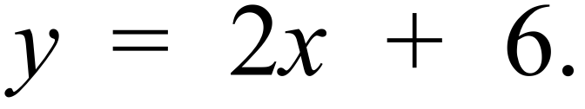 (N.B. The scales on the two axes are not equal in the diagram)
 | - Show that C is equidistant from A and B.  ………………………………………………………………………………………..  ………………………………………………………………………………………..  ………………………………………………………………………………………..  ……………………………………………………………………………………….. | 2
 | - Show that 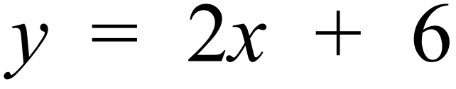 is perpendicular to AB.  ………………………………………………………………………………………..  ………………………………………………………………………………………..  ……………………………………………………………………………………….. | 2
82. | - Solve 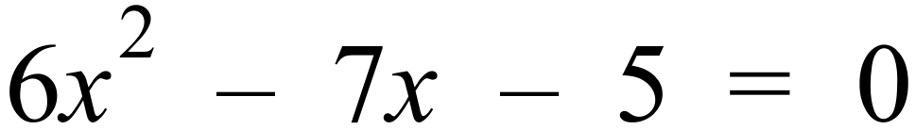.  ………………………………………………………………………………………..  ………………………………………………………………………………………..  ……………………………………………………………………………………….. | 1
 | - Find the exact value(s) of a, in simplest form, for which 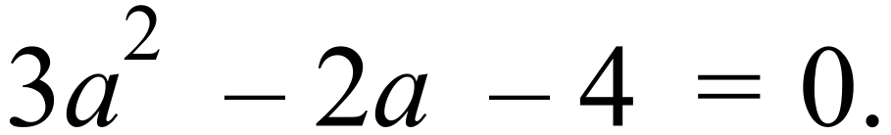  ………………………………………………………………………………………..  ………………………………………………………………………………………..  ………………………………………………………………………………………..  ……………………………………………………………………………………….. | 2
83. | The graph of 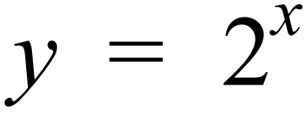 is shown on the number plane below.  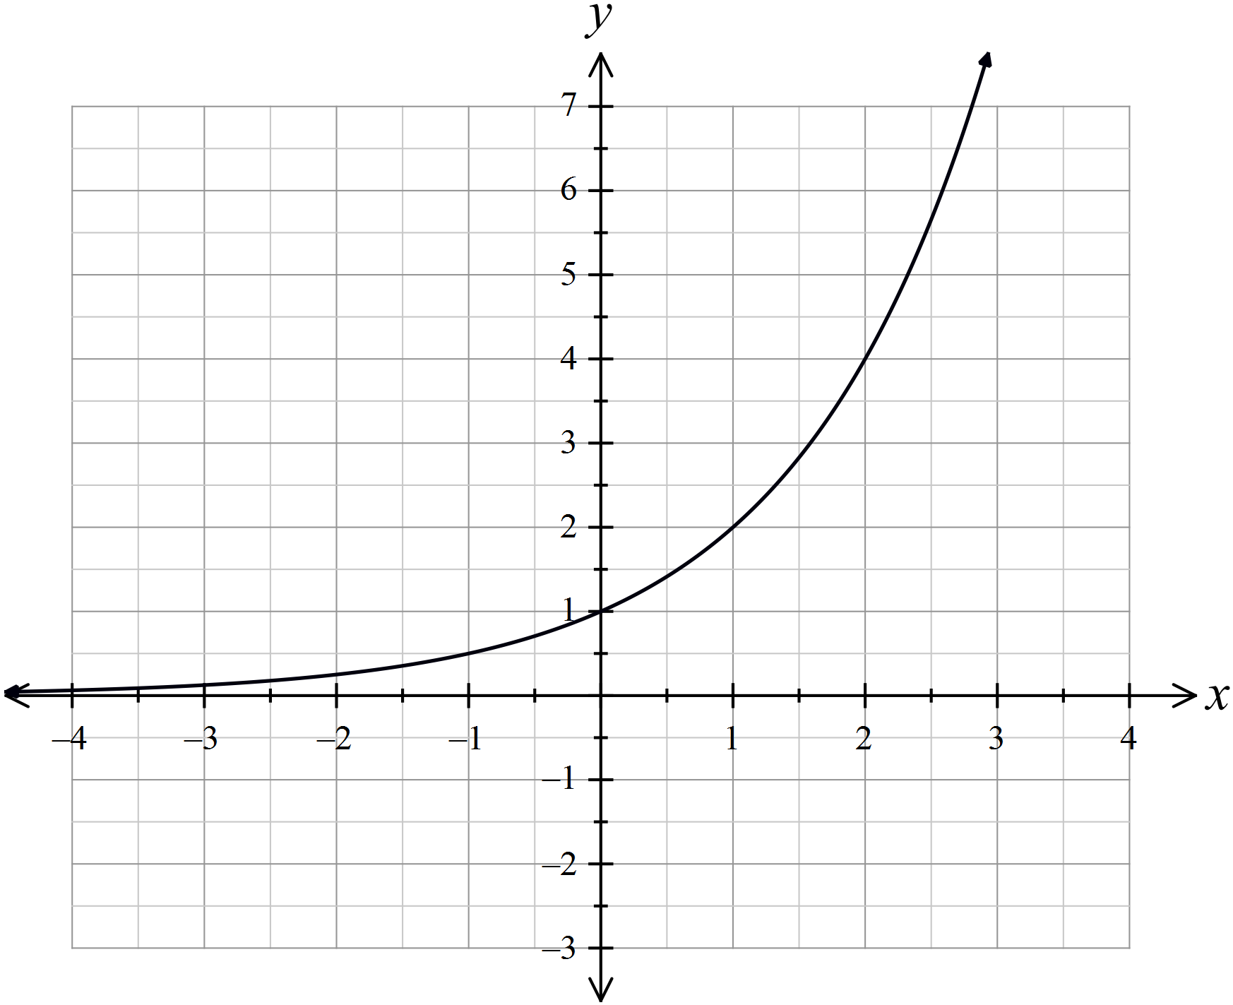
 | - On the same number plane, draw the graph of 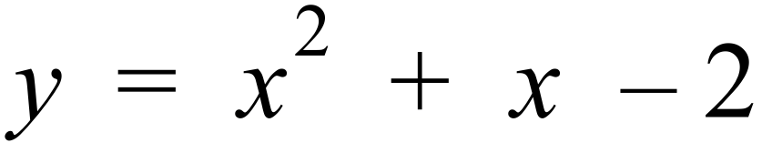.  ………………………………………………………………………………………..  ………………………………………………………………………………………..  ……………………………………………………………………………………….. | 2
 | - Use the graphs to approximate the solutions to the equation 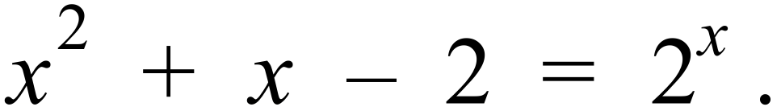  ………………………………………………………………………………………..  ………………………………………………………………………………………..  ……………………………………………………………………………………….. | 1
 | End of Examination

School Name
Year 10 Yearly Examination
Advanced Mathematics Course 2016
Multiple Choice Section Answer Sheet

Name ________________________________ Teacher ________________________

Completely fill the response oval representing the most correct answer.
Use a black or blue pen or 2B pencil.

26. A B C D
27. A B C D
28. A B C D
29. A B C D
30. A B C D
31. A B C D
32. A B C D
33. A B C D
34. A B C D
35. A B C D
36. A B C D
37. A B C D
38. A B C D
39. A B C D
40. A B C D
41. A B C D
42. A B C D
43. A B C D
44. A B C D
45. A B C D
46. A B C D
47. A B C D
48. A B C D
49. A B C D
50. A B C D

51. A B C D
52. A B C D
53. A B C D
54. A B C D
55. A B C D
56. A B C D
57. A B C D
58. A B C D
59. A B C D
60. A B C D
61. A B C D
62. A B C D
63. A B C D
64. A B C D
65. A B C D
66. A B C D
67. A B C D
68. A B C D
69. A B C D
70. A B C D
71. A B C D
72. A B C D
73. A B C D
74. A B C D
75. A B C D

